ThyroCheck: Hypertension & Disease Risk Predictor



Project ID: Fall-2025-32

Session: BSCS Fall 2022 to 2026

Project Advisor: Dr. Khurram Ejaz Submitted By

Muhammad Shayan Akram | 70131438
Muhammad Noor Sultan | 70131318
Dua Ali | 70077945

Department of Computer Science & IT The University of Lahore

Lahore, Pakistan

Declaration
We have read the project guidelines and we understand the meaning of academic dishonesty, in particular plagiarism and collusion. We hereby declare that the work we submitted for our final year project, entitled ThyroCheck: Smoker, Hypertension & Disease Risk Predictor is original work and has not been printed, published or submitted before as final year project, research work, publication or any other documentation.

Group Member 1 Name: Muhammad Shayan Akram SAP No: 70131438

Signature: …………………………

Group Member 2 Name: Muhammad Noor Sultan SAP No: 70131318

Signature: …………………………

Group Member 3 Name: Dua Ali SAP No: 70077945

Signature: …………………………

Statement of Submission

This is to certify that Muhammad Shayan Akram Roll No. 70131438, Muhammad Noor Sultan Roll No. 70131318 and Dua Ali Roll No. 70077945 have successfully submitted the final project named as: ThyroCheck: Smoker, Hypertension & Disease Risk Predictor, at Computer Science & IT Department, The University of Lahore, Lahore Pakistan, to fulfill the partial requirement of the degree of BS in Computer Science.

Supervisor Name: Dr. Khurram Ejaz

Signature: ………………………… Date: ………………………

Dedication
This project is dedicated to my father, who taught me that the best kind of knowledge to have is which is learned for its own sake. It is also dedicated to my mother, who taught me that even the largest task can be accomplished if it is done one step at a time. This project is also dedicated to our teachers who taught us well, created our interest in such fields and made us capable enough to create something of our own. This project is also dedicated to us as for our motivation and dedication to the field of work.

Acknowledgement

We truly acknowledge the cooperation and help made by Name of Dr. Khurram Ejaz, Assistant Professor of The University of Lahore. He has been a constant source of guidance throughout the course of this project. We are also thankful to our friends and families whose silent support led us to complete our project.

Date:

Abstract
Thyroid disorders are among the most prevalent endocrine diseases and are often associated with long-term complications affecting multiple physiological systems, particularly cardiovascular and metabolic functions. Interpreting thyroid laboratory reports can be challenging for patients, leading to delayed awareness of potential health risks. ThyroCheck proposes a mobile-based intelligent health risk assessment system that integrates Optical Character Recognition (OCR), Machine Learning (ML), and cloud-based backend services to analyze thyroid laboratory reports and provide multi-domain risk evaluation.

The proposed solution is implemented as a cross-platform React Native mobile application that enables users to securely sign up and sign in, upload or scan thyroid laboratory reports in image or PDF format, and maintain historical health records. Firebase Authentication is used to manage secure user access, while Firebase Cloud Firestore serves as the backend database for storing extracted report values, prediction results, and user history in a structured and privacy-aware manner. Uploaded reports are processed on a Python-based backend, where OCR techniques are applied to automatically extract thyroid hormone values such as TSH, T3, and T4.

The extracted data, along with demographic and lifestyle information, is fed into trained machine learning models to assess hypertension risk and estimate future health risk levels across three independent domains: cardiovascular risk, metabolic complication risk, and thyroid-related complication risk. Each risk is reported using categorical levels (Low, Medium, High) to ensure interpretability and clinical safety. ThyroCheck generates a comprehensive PDF report summarizing extracted laboratory values, risk predictions, and explanatory insights for the user.

ThyroCheck is designed as a decision-support system rather than a diagnostic tool and incorporates ethical considerations related to data privacy and medical responsibility. This project demonstrates the effective integration of mobile application development, OCR-based data extraction, machine learning–driven risk assessment, and cloud-based data management to enhance early health risk awareness and accessibility to intelligent healthcare support solutions.

Area of the Project

Artificial Intelligence (AI): Uses intelligent algorithms to analyze thyroid data and provide risk assessments.

Machine Learning (ML): Trains models to predict hypertension and multi-domain health risks from extracted features.

Healthcare Informatics: Applies AI/ML to interpret medical reports and support patient health awareness.

Mobile Application Development: Implements a React Native app for user-friendly report upload and result display.

Optical Character Recognition (OCR): Automatically extracts thyroid hormone values from images and PDFs.

Cloud-Based Systems / Firebase: Manages secure user authentication and stores report data in the cloud.

Decision Support Systems (DSS): Provides risk-based insights to assist users in understanding potential health complications.

Technologies used

The technologies used in this project include React Native, React Navigation, Expo Image Picker, React Native Document Picker, React Native PDF, Python, Flask, Pandas, NumPy, Scikit-learn, XGBoost, OpenCV, Pillow, EasyOCR, Tesseract OCR, Firebase Authentication, Firebase Cloud Firestore, ReportLab, Regex, Git & GitHub, Visual Studio Code (VS Code), Android Studio / Emulator and Matplotlib/Seaborn.

List of Figures
Figure 1 Product Perspective Architectural Diagram 9
Figure 2 User Registration Use Case Diagram 24
Figure 3 User Login Use Case Diagram 25
Figure 4 User Password Reset Use Case Diagram 26
Figure 5 User Providing Smoking Status Use Case Diagram 28
Figure 6 Upload Thyroid Reports Use Case Diagram 29
Figure 7 OCR Error & Prompt for Re-Uploading 30
Figure 8 Extract TSH, T3 & T4 Value Using OCR Use Case Diagram 31
Figure 9 Storing Data for ML Processing Use Case Diagram 32
Figure 10 Predict Hypertension Status Using ML Model Use Case Diagram 33
Figure 11 Risk Assessment Use Case Diagram 35
Figure 12 PDF Report Use Case Diagram 37
Figure 13 View & Download PDF Reports Use Case Diagram 38
Figure 14 Notifying User PDF Report is ready Use Case Diagram 39
Figure 15 Storage and Historical Reports & Results Use Case Diagram 40
Figure 16 Securely Store User Data Use Case Diagram 41
Figure 17 Handle Multiple User Use Case Diagram 42
Figure 18 Manage Cloud Storage Use Case Diagram 43
Figure 19 Architecture Diagram 44
Figure 20 ERD with Data Dictonary 45
Figure 21 Data Flow Diagram Level 0 46
Figure 22 Data Flow Diagram Level 1 47
Figure 23 Class Diagram 48
Figure 24 User Registration Activity Diagram 49
Figure 25 User Login Activity Diagram 50
Figure 26 Password Reset Activity Diagram 51
Figure 27 User Provide Smoking Status Activity Diagram 52
Figure 28 Upload Thyroid Report Upload Activity Diagram 53
Figure 29 Flag OCR Error & Prompt for Re-Upload Activity Diagram 54
Figure 30 Extraction of TSH, T3 and T4 values using OCR 55
Figure 31 Risk Assessment Diagram 56
Figure 32 Generate PDF Report Activity Diagram 57
Figure 33 View and Download PDF Reports Activity Diagram 58
Figure 34 Store and Manage historical Reports and Results Activity Diagram 59
Figure 35 Securely Store Data in Firebase Activity Diagram 60
Figure 36 Handle Multiple users securely Activity Diagram 61

Figure 37 Managing Cloud Storage Usage Activity Diagram 62
Figure 38 Sequence Diagram User Registration 63
Figure 39 Sequence Diagram User Sign-In 64
Figure 40 Sequence Diagram Password Reset 65
Figure 41 Sequence Diagram Smoking Status 66
Figure 42 Sequence Diagram Upload Thyroid Reports 67
Figure 43 Sequence Diagram Validate Uploaded Capture Quality 68
Figure 44 Sequence Diagram Extract TSH, T3 & T4 Values 69
Figure 45 Sequence Diagram Risk Assessment 70
Figure 46 Sequence Diagram PDF Report Generation 71
Figure 47 Sequence Diagram View Download PDF Report 72
Figure 48 Sequence Diagram Store and Manage Historical Reports and Results 73
Figure 49 Sequence Diagram Handle Multiple Users 74
Figure 50 Sequence Diagram Dynamically Manage Cloud Storage 75
Figure 51 State Transition Diagram 76
Figure 52 Component Diagram 77
Figure 53 Deployment Diagram 78
Figure 54 User Interface - Login Page 79
Figure 55 User Interface - Sign Up Page 81
Figure 56 User Interface - Home Page 82
Figure 57 User Interface - Profile Page 83
Figure 58 User Interface - Report Page 84
Figure 59 User Interface - Password Reset Page 85

List of Tables

Table 1 Acronyms 6
Table 2 Abbreviations 6
Table 3 FR User Registration 10
Table 4 FR User Login 10
Table 5 FR Password Reset 11
Table 6 FR Report Upload 11
Table 7 FR Scan Report 12
Table 8 FR OCR Extraction 12
Table 9 FR OCR Error Handling 13
Table 10 FR Hypertension Prediction 13
Table 11 FR Cardiovascular Risk Assessment 14
Table 12 FR Metabolic Risk Assessment 14
Table 13 FR Thyroid Risk Assessment 15
Table 14 FR PDF Report Generation 15
Table 15 FR View & Download PDF Reports 16
Table 16 FR Store and Manage Historical Reports and Results 16
Table 17 FR Secure Store User Data in Firebase 17
Table 18 FR Handle Multiple Users Securely 17
Table 19 FR Dynamically Manage Cloude Storage Usage 18
Table 20 User Registration Use Case Diagram 24
Table 21 User Login Use Case Table 25
Table 22 User Password Reset Use Case Table 27
Table 23 User Smoking Status Use Case Table 28
Table 24 Upload Thyroid Use Case Table 29
Table 25 Flag OCR Error and Prompt for Re-Uploading Use Case Table 30
Table 26 Extract TSH, T3 & T4 Value using OCR Use Case Table 31
Table 27 Storing Data for ML Processing Use Case Table 32
Table 28 Predict Hypertension Status Using ML Model Use Case Table 34
Table 29 Risk Assessment Use Case Table 36
Table 30 Generate PDF Report Use Case Table 37
Table 31 View and Download Use Case Table 38
Table 32 Notifying User PDF Report is ready Use Case Table 39
Table 33 Storage and Historical Reports and Result Use Case Table 40
Table 34 Securely Store User Data Use Case Table 41
Table 35 Handle Multiple Users Securely Data Use Case Table 42
Table 36 Manage Cloud Storage Use Case Table 43

Table of Content

Declaration i
Statement of Submission ii
Dedication iii
Acknowledgement iv
Abstract v
List of Figures vii
List of Tables ix
Chapter 1: Introduction to the Problem 1
  - Introduction 1
  - Purpose 1
  - Objective 2
  - Existing Solution 2
  - Proposed Solution 3
Chapter 2: Software Requirement Specification 4
  - Introduction 4
    - Purpose 4
    - Scope 4
    - Definitions, acronyms, and abbreviations 5
Acronyms 6
  - Overall description 7
    - Product perspective 7
- System Interfaces 7
- User Interfaces (Screenshots of interfaces are given in the User Manual in Chapter 5) 7
- Hardware Interfaces 8
- Software Interfaces 8
- Communication Interfaces 8
- Memory 8
- Operations 8
- Site Adaptation Requirements 8
Architectural Diagram 9
    - Product functions 10
    - User characteristics 19
    - Constraints 19
Regulatory Policies 19
Hardware Limitations 19
Interfaces to Other Applications 20
Parallel Operation 20
Audit Functions 20
Control Functions 20
Higher-Order Language Requirements 20
Signal Handshake Protocols 20
Reliability Requirements 20
    - Assumptions and dependencies 21
    - Apportioning of requirements 21
  - Specific requirements 21
    - Functional Requirements 21
    - Non-functional Requirements 22
Chapter 3: Use Case Analysis 24
Chapter 4: Design 44
  - Architecture Diagram 44
  - ERD with data dictionary 45
  - Data Flow diagram 46
Data flow diagram includes two levels and both of them are given below 46
    - The level 0 46
    - The level 1 47
  - Class Diagram 48
  - Activity Diagram 49
  - Sequence Diagram 63
  - Component Diagram 77
  - Deployment Diagram 78
Chapter 5: User Manual 79
References 86
Appendix 87

Chapter 1: Introduction to the Problem

Introduction

Thyroid disorders are among the most common endocrine diseases worldwide and are frequently associated with other chronic health conditions, particularly hypertension, cardiovascular diseases, and metabolic disorders. Abnormal levels of thyroid hormones such as Thyroid Stimulating Hormone (TSH), Triiodothyronine (T3), and Thyroxine (T4) can influence blood pressure regulation and metabolic balance, potentially leading to long-term complications. Early identification of hypertensive status and related health risks in patients with thyroid abnormalities is therefore crucial for timely intervention and prevention. Despite the availability of thyroid laboratory testing, many patients face significant difficulty in interpreting their reports and understanding whether they are hypertensive or non-hypertensive, as well as the potential health risks associated with their condition. Medical reports are often complex and require professional interpretation, which may not always be accessible during short clinical consultations. As a result, patients may remain unaware of both their hypertension status and their broader risk of developing cardiovascular, metabolic, or thyroid-related complications.

In addition, thyroid laboratory reports are commonly stored as paper documents, scanned images, or PDF files, making manual analysis and long-term health tracking inefficient. Existing digital health solutions often lack automated report interpretation, hypertension prediction, and multi- domain risk assessment within a single integrated platform. Most systems focus on isolated conditions and do not provide a comprehensive overview of how thyroid disorders can simultaneously affect multiple physiological systems. With the growing adoption of mobile health technologies, there is a clear need for an intelligent, mobile-based decision-support system that can automatically extract thyroid hormone values from laboratory reports, predict whether a patient is hypertensive or non-hypertensive, and evaluate potential health risks across three independent domains: cardiovascular risk, metabolic complication risk, and thyroid-related complication risk. Addressing this problem through the integration of Optical Character Recognition (OCR), machine learning, and cloud-based services can enhance early health awareness, improve accessibility to personalized health insights, and support informed decision-making while maintaining ethical standards and data privacy.

Purpose

The purpose of this project is to develop a mobile-based intelligent health assessment system that enables users to predict whether a patient is hypertensive or non-hypertensive based on thyroid laboratory data. ThyroCheck aims to simplify the interpretation of thyroid reports by automatically

extracting key hormone values such as TSH, T3, and T4 using Optical Character Recognition (OCR) techniques. Another key purpose of the project is to apply machine learning models to predict hypertension status and to evaluate potential health risks across three independent domains: cardiovascular risk, metabolic complication risk, and thyroid-related complication risk. These risk outcomes are presented in categorized levels (Low, Medium, High) to ensure interpretability and to support user understanding without replacing professional medical diagnosis. Additionally, the project aims to provide a secure and centralized platform for managing personal health records. Through the integration of cloud-based authentication and database services, ThyroCheck allows users to securely store, track, and review historical thyroid reports, hypertension predictions, and multi-domain risk assessments. Overall, the purpose of this project is to enhance early health awareness, support informed decision-making, and improve accessibility to intelligent, technology driven healthcare decision-support solutions.

Objective

    - To Purpose a Preprocessing Method for Thyroid Hormonal dataset due to noise imaging.
    - To Propose a classification method to detect the patient as hypertensive or non-hypertensive and analyze the risk, issue was accurate identification.
    - To Propose an automatic report generation method the reason was manual interpretation.

Existing Solution

Currently, there are several digital health applications and systems that assist patients in monitoring thyroid-related health and managing laboratory reports. Many mobile applications focus on tracking thyroid hormone levels or storing medical records, but they usually require manual input of laboratory data, which is time-consuming and prone to errors. Some platforms provide basic visualization of lab trends, but they do not offer automated interpretation or risk assessment for users. Other existing solutions focus on hypertension monitoring using wearable devices or manual data entry but rarely integrate thyroid hormone data into their analysis. Similarly, while some

online healthcare portals offer risk calculators for cardiovascular or metabolic conditions, these tools are often generic, not personalized, and not integrated with real thyroid lab reports.

Moreover, most current systems do not provide multi-domain risk predictions in a single platform, nor do they generate comprehensive, downloadable reports for the user. Integration of OCR for automatic extraction of lab values and machine learning for predictive analysis is largely absent in existing solutions, limiting usability and accuracy.

In summary, existing solutions either focus on a single aspect of patient health, require manual data handling, or do not combine thyroid analysis with hypertension prediction and multi-domain risk assessment, leaving a significant gap for a fully integrated, intelligent, and mobile-based decision- support system.

Proposed Solution

To address the limitations of existing systems, this project proposes a mobile-based intelligent healthcare decision-support system that integrates Optical Character Recognition (OCR), Machine Learning (ML), and cloud-based data management. The solution enables users to automatically extract thyroid hormone values (TSH, T3, T4) from uploaded or scanned laboratory reports and predicts whether a patient is hypertensive or non-hypertensive. In addition, ThyroCheck evaluates potential health risks across three independent domains: cardiovascular risk, metabolic complication risk, and thyroid-related complication risk, presenting results in Low, Medium, or High categories for clarity and interpretability.
ThyroCheck is implemented as a cross-platform React Native mobile application, allowing users to securely sign up and log in through Firebase Authentication. Users can upload or capture laboratory reports in image or PDF format, which are processed on a Python-based backend. OCR techniques extract numerical values, which are then preprocessed and fed into trained machine learning models to generate predictions and multi-domain risk assessments.

Chapter 2: Software Requirement Specification

Introduction

Purpose

The purpose of this Software Requirement Specification (SRS) is to clearly define the functional and non-functional requirements of the ThyroCheck mobile-based intelligent health assessment system. ThyroCheck is designed to assist users in predicting whether a patient is hypertensive or non-hypertensive based on thyroid laboratory data and to evaluate potential health risks across three independent domains: cardiovascular, metabolic, and thyroid-related complications.

ThyroCheck aims to simplify the interpretation of thyroid laboratory reports by automatically extracting hormone values (TSH, T3, T4) using OCR techniques, predicting hypertension status through machine learning models, and providing multi-domain risk assessments in Low, Medium, or High categories. Additionally, it ensures secure storage of user data, generates comprehensive PDF reports, and supports users in making informed health-related decisions as a decision-support tool while maintaining ethical and privacy standards.

Scope

The scope of the proposed system includes the following:

      - Development of a cross-platform mobile application using React Native for analyzing thyroid laboratory reports.
      - Implementation of secure user authentication and account management through Firebase
Authentication.
      - Automatic extraction of thyroid hormone values (TSH, T3, T4) from uploaded or scanned images and PDF reports using OCR techniques.
      - Prediction of the user’s hypertension status (hypertensive or non-hypertensive) through trained machine learning models.
      - Assessment of multi-domain health risks, specifically:
        - Cardiovascular risk
        - Metabolic complication risk
        - Thyroid-related complication risk
      - Presentation of risk levels in Low, Medium, or High categories for better interpretability.
      - Generation of comprehensive PDF reports summarizing extracted values, hypertension prediction, and domain-specific risk levels.

      - Secure cloud storage of user data, reports, and prediction results using Firebase Cloud Firestore.
      - Provision of a decision-support platform without functioning as a medical diagnostic tool, ensuring ethical compliance and data privacy.

ThyroCheck focuses on providing early health awareness and personalized insights, enabling users to make informed health-related decisions. It does not replace clinical diagnosis or treatment but serves as an intelligent support tool for thyroid and hypertension monitoring.

Definitions, acronyms, and abbreviations Definitions: -
      - TSH (Thyroid Stimulating Hormone): A hormone that regulates the production and release of thyroid hormones.
      - T3 (Triiodothyronine): A thyroid hormone responsible for regulating metabolism and energy levels.
      - T4 (Thyroxine): A thyroid hormone that helps control metabolic processes in the body.
      - Hypertension: A condition in which blood pressure remains persistently higher than normal levels.
      - Optical Character Recognition (OCR): A technology used to extract readable text from images or scanned documents.
      - Machine Learning (ML): A computational approach that enables systems to learn from data and make predictions.
      - Artificial Intelligence (AI): The capability of machines to perform tasks that normally require human intelligence.
      - Firebase Authentication: A service used to securely manage user login and access control.
      - Firebase Cloud Firestore: A cloud-based database used to store and manage application data.
      - Decision-Support System: A system designed to assist users in decision-making without providing medical diagnosis.
      - Cardiovascular Risk: The likelihood of developing heart or blood vessel-related complications.
      - Metabolic Complication Risk: The likelihood of developing metabolic disorders.
      - Thyroid-Related Complication Risk: The likelihood of developing complications related to thyroid dysfunction.
      - React Native: A framework used to develop cross-platform mobile applications using JavaScript and React.
      - Flask: A lightweight Python web framework used to build backend APIs.
      - Firebase: A cloud-based platform providing authentication, database, and backend services.

      - Cloud Firestore: A NoSQL cloud database for storing and synchronizing application data.
      - Application Programming Interface (API): A set of rules that enables communication between different software components.

Acronyms: -

Acronym | Description
AI | Artificial Intelligence
ML | Machine Learning
OCR | Optical Character Recognition
API | Application Programming Interface
PDF | Portable Document Format
SRS | Software Requirement Specification
UI | User Interface
UX | User Experience
DB | Database
DSS | Decision Support System
FYP | Final Year Project

Table 1 Acronyms

Abbreviations: -

Abbreviation | Description
TSH | Thyroid Stimulating Hormone
T3 | Triiodothyronine
T4 | Thyroxine
OCR | Optical Character Recognition
ML | Machine Learning
AI | Artificial Intelligence
API | Application Programming Interface
DB | Database
NoSQL | Non-Relational Structured Query Language
DSS | Decision Support System
PDF | Portable Document Format

Table 2 Abbreviations

Overall description

Product perspective

ThyroCheck is a self-contained mobile application built using React Native. It integrates Google Firebase for secure user authentication and cloud-based data storage, and a Python Flask backend for OCR processing and machine learning model training and inference. The machine learning models are trained as part of this project to predict hypertension status and assess multi-domain health risks. ThyroCheck is self-contained and does not rely on any other external software systems. All the interfaces and characteristics are given as follows:

System Interfaces
        - Firebase Authentication for managing secure user accounts.
        - Firebase Cloud Firestore for storing user profiles, extracted thyroid report values, hypertension prediction results, multi-domain risk assessments, and historical health records.
        - Python Flask REST API for OCR processing, trained ML model inference, and communication between the mobile app and backend services.
        - OCR Engine (Tesseract / EasyOCR) for extracting text from uploaded or scanned thyroid laboratory reports.
        - Machine Learning Models developed and trained within this project to predict hypertension status and multi-domain health risks.

      - User Interfaces (Screenshots of interfaces are given in the User Manual in Chapter 5)

        - Role-based access directing users to appropriate interfaces.

Screens include:
          - Login / Signup / Forgot Password
          - Home Dashboard
          - Upload or Scan Thyroid Report (Image / PDF)
          - Extracted Report Values Display
          - Hypertension Prediction Result (Hypertensive / Non-Hypertensive)
          - Multi-Domain Risk Assessment (Cardiovascular, Metabolic, Thyroid- related)
          - Generated PDF Report View and Download
          - User History and Saved Reports

Hardware Interfaces

        - Mobile devices running Android (and optionally iOS) operating systems.
        - Camera access for capturing thyroid laboratory reports.
        - Internet connectivity required for cloud communication and backend API access.

Software Interfaces

        - React Native Framework for cross-platform mobile development.
        - Firebase SDK (Authentication and Cloud Firestore).
        - Python Flask backend with REST APIs for ML inference and OCR processing.
        - OCR Libraries (Tesseract / EasyOCR).
        - Machine Learning Libraries (Scikit-learn, NumPy, Pandas).
        - PDF Generation Library (ReportLab).

Communication Interfaces

        - HTTPS protocol for secure communication between ThyroCheck and backend.
        - Firebase secure channels for real-time synchronization and authentication.

Memory

        - ThyroCheck must run efficiently on devices with at least 4 GB RAM.
        - Cloud storage is managed dynamically via Firebase Cloud Firestore.

Operations

        - Standard mobile app installation.
        - No specialized operations required by the user.
        - Automatic data backup and synchronization are managed by Firebase.

Site Adaptation Requirements

        - No special site adaptations are required.
        - ThyroCheck is cloud-hosted, enabling access from any geographic region with intern

Architectural Diagram:
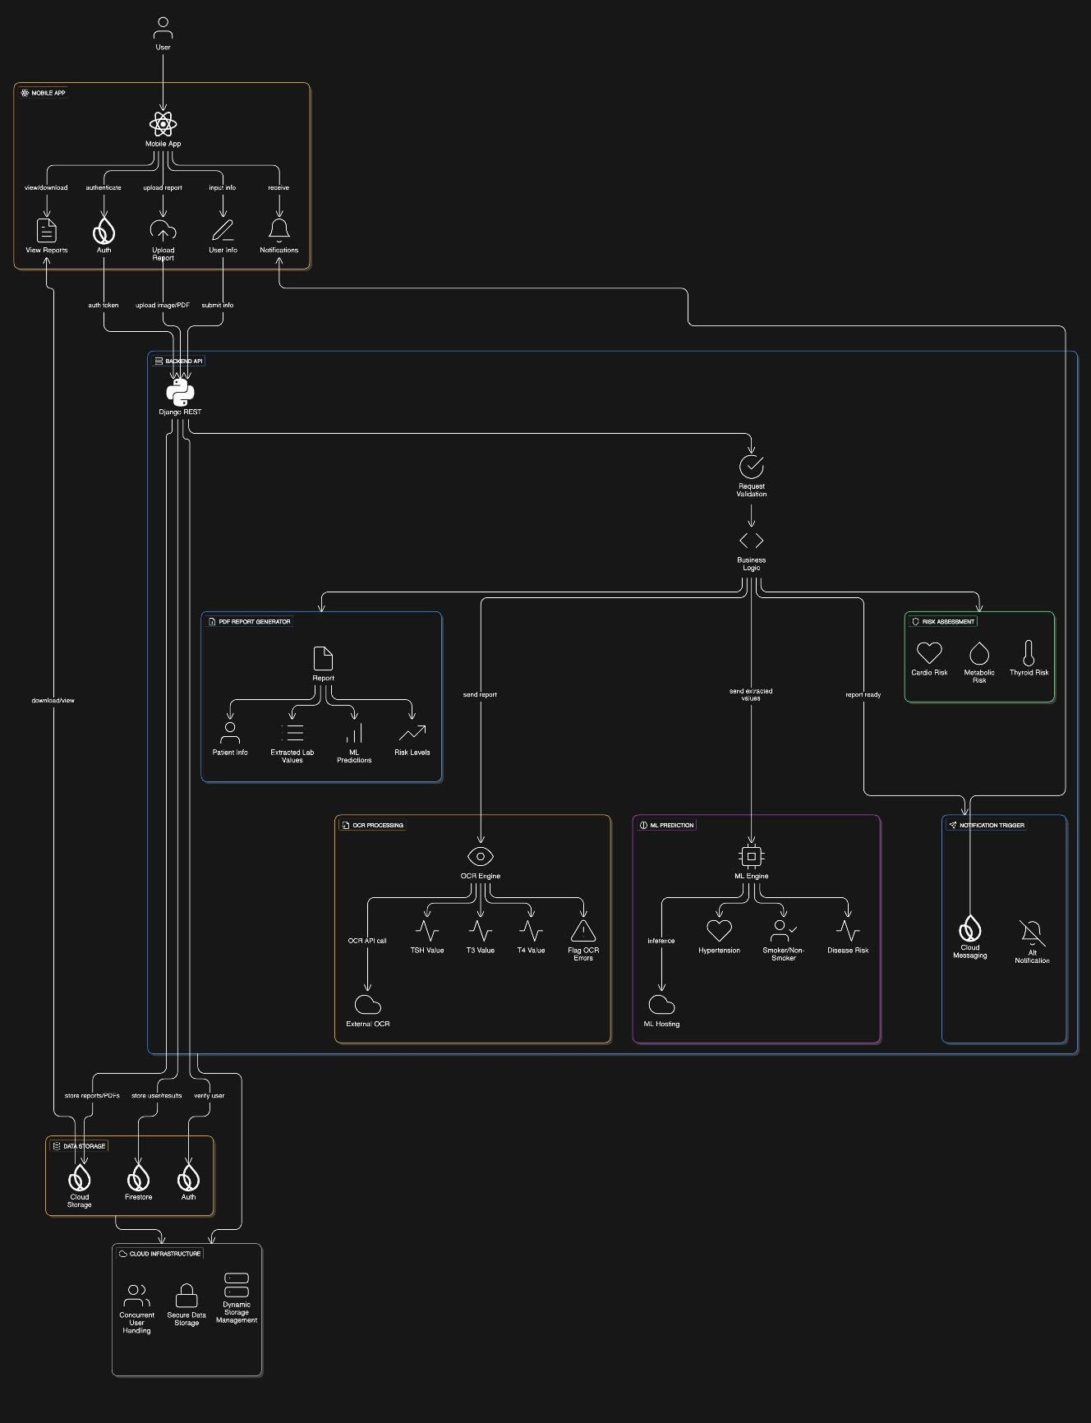
Figure 1 Product Perspective Architectural Diagram

Product functions

All the functional requirements for our project are defined below:

      - Module: User Registration

ID: | UR_01(User)
Name: | User Registration
Description | Input | Output | Requirements | Basic Work Flow
Users should be able to register with email and password. | User inputs the credentials for account creation | After verification and validation, a new user is formed. | Must enter valid credentials and verify email | Credential input → Automatic email verification → Verification → User registered

Table 3 FR User Registration
      - Module: User Login

ID: | UL_01 (User)
Name: | User Login
Description | Input | Output | Requirements | Basic Work Flow
Users should be able to login with verified email and password. | User inputs the credentials for account login. | User logins the app. | Must enter valid credentials and must be a verified user. | Credential Input by the user → Check if the user is validated or not  → Login (Verified) / Account Verification Notification.

Table 4 FR User Login

      - Module: Password Reset

ID: | PR_01 (User)
Name: | Password Reset
Description | Input | Output | Requirements | Basic Work Flow
Users should be able to reset the password. | User clicks on “Forgot Password”  / “Reset Password” | A mail verification is sent with the link to reset the password | User must be a verified user. | User presses “Forgot Password” / “Reset Password” → Verification link with reset functionality sent to the user → User Password updated.

Table 5 FR Password Reset

      - Module: Report Upload

ID: | PR_01 (User)
Name: | Report Upload
Description | Input | Output | Requirements | Basic Work Flow
Users should be able to upload PDF or image reports. | Report file (PDF/Image) | A mail verification is sent with the link to reset the password | Report stored in database | User selects file → Click upload → System validates  → Report saved

Table 6 FR Report Upload

      - Module: Scan Report

ID: | RP_02
Name: | Scan Report
Description | Input | Output | Requirements | Basic Work Flow
Users should be able to capture thyroid report images using camera. | Camera Image or PDF | Image saved for processing | Camera access and Interent required | User opens camera → Captures image → Confirms → Image saved

Table 7 FR Scan Report

      - Module: OCR Extraction

ID: | EX_01
Name: | Extract Values
Description | Input | Output | Requirements | Basic Work Flow
Extract TSH, T3, and T4 values from report | Uploaded/Scanned report | Extracted hormone values | OCR engine required | System applies OCR → Extracts hormone values → Values saved for ML

Table 8 FR OCR Extraction

      - Module: OCR Error Handling

ID: | EX_02
Name: | Flag OCR Errors
Description | Input | Output | Requirements | Basic Work Flow
Detect errors in OCR extraction and notify user. | OCR Result | Error message / Retry prompt | Internet Required | System checks OCR → If error → Notify user → User re-uploads

Table 9 FR OCR Error Handling

      - Module: Hypertension Prediction

ID: | ML_01
Name: | Predict Hypertension
Description | Input | Output | Requirements | Basic Work Flow
Predict if the user is hypertensive or non-hypertensive | Extracted hormone values, demographic info | Hypertensive  / non- hypertensive | ML model trained and internet required | Feed values to ML model  → Predict → Store result

Table 10 FR Hypertension Prediction

      - Module: Cardiovascular Risk Assessment

ID: | ML_02
Name: | Cardiovascular Risk Prediction
Description | Input | Output | Requirements | Basic Work Flow
Assess cardiovascular risk based on extracted values | Hormone values, demographics | Low / Medium / High | Trained ML model required | ML model evaluates → Risk level displayed → Stored in Firebase

Table 11 FR Cardiovascular Risk Assessment

      - Module: Metabolic Risk Assessment

ID: | ML_03
Name: | Metabolic Risk Prediction
Description | Input | Output | Requirements | Basic Work Flow
Assess Metabolic risk based on extracted values | Hormone values, demographics | Low / Medium / High | Trained ML model required | ML model evaluates → Risk level displayed → Stored in Firebase

Table 12 FR Metabolic Risk Assessment

      - Module: Thyroid Risk Assessment

ID: | ML_04
Name: | Thyroid Risk Prediction
Description | Input | Output | Requirements | Basic Work Flow
Assess Thyroid risk based on extracted values | Hormone values, demographics | Low / Medium / High | Trained ML model required | ML model evaluates → Risk level displayed → Stored in Firebase

Table 13 FR Thyroid Risk Assessment

      - Module: PDF Report Generation

ID: | PR_01
Name: | Generate PDF Report
Description | Input | Output | Requirements | Basic Work Flow
Generate PDF containing extracted values and predictions. | Extracted values and predictions | PDF Report | PDF library required | System generates PDF → Stores in Firebase → Ready to view/download

Table 14 FR PDF Report Generation

      - Module: View and Download PDF Reports

ID: | PR_02
Name: | View and Download PDF Reports
Description | Input | Output | Requirements | Basic Work Flow
Allows users to access previously generated PDF reports and download them securely. | User request for report | Displayed or downloaded PDF report | User authentication, Firebase Storage | System verifies user → Retrieves PDF from Firebase → Displays or downloads report

Table 15 FR View & Download PDF Reports

      - Module: Store and Manage Historical Reports and Results

ID: | PR_03
Name: | Store and Manage Historical Reports and Results
Description | Input | Output | Requirements | Basic Work Flow
Maintains a historical record of uploaded reports, predictions, and generated PDFs. | Generated reports and prediction results | Archived historical reports | Database system, cloud storage | System stores report data → Updates history records → Allows retrieval when requested

Table 16 FR Store and Manage Historical Reports and Results

      - Module: Securely Store User Data in Firebase

ID: | PR_04
Name: | Securely Store User Data in Firebase
Description | Input | Output | Requirements | Basic Work Flow
Ensures user data is securely stored and protected using Firebase services. | User personal and medical data | Encrypted user data stored in Firebase | Firebase Authentication, Firebase Database | System encrypts data → Stores data in Firebase → Confirms secure storage

Table 17 FR Secure Store User Data in Firebase

      - Module: Handle Multiple Users Securely

ID: | PR_06
Name: | Handle Multiple Users Securely
Description | Input | Output | Requirements | Basic Work Flow
Manages concurrent access by multiple users while maintaining data security and isolation. | Multiple user requests | Secure and isolated user sessions | Session management, authentication system | User sessions validated → Requests processed securely → Data access isolated

Table 18 FR Handle Multiple Users Securely

      - Module: Dynamically Manage Cloud Storage Usage

ID: | PR_07
Name: | Dynamically Manage Cloud Storage Usage
Description | Input | Output | Requirements | Basic Work Flow
Monitors and optimizes cloud storage to prevent overuse and ensure availability. | Storage usage data | Optimized storage allocation | Cloud storage service, monitoring tools | System monitors usage → Applies limits or cleanup → Updates storage status

Table 19 FR Dynamically Manage Cloude Storage Usage

User characteristics

This subsection describes the general characteristics of the intended users of the ThyroCheck mobile application. The system is designed to be used by a diverse group of users with varying educational backgrounds, technical skills, and experience levels.
The primary users of the system are patients who wish to analyze thyroid laboratory reports and receive health-related insights. These users may have basic to moderate educational backgrounds and limited technical expertise. Therefore, the application is designed with a simple and user- friendly interface that requires minimal technical knowledge to operate.
Users are expected to have basic familiarity with smartphones, including the ability to install applications, upload images or PDF files, and navigate through mobile app screens. No prior medical or technical expertise is required to use the system effectively.
Secondary users include system administrators who manage backend services, data storage, and system monitoring. Administrators are expected to have a higher level of technical expertise, including experience with cloud services, databases, and system maintenance.
Overall, the system accommodates users with varying levels of experience by providing clear instructions, error messages, and guided workflows to ensure ease of use and accessibility.

Constraints
This subsection provides a general description of the constraints and dependencies that may limit the developer’s design and implementation choices for the ThyroCheck system. These constraints must be considered throughout the system development lifecycle.

Regulatory Policies
The system shall comply with applicable data protection and privacy regulations. User medical data and personal information shall be handled securely, ensuring confidentiality and ethical use. Access to sensitive information shall be restricted to authorized users only.

Hardware Limitations
The application shall operate on standard Android and iOS mobile devices with limited processing power and memory. Heavy computational tasks such as OCR processing and machine learning predictions shall be handled on the server side to minimize device resource usage.

Interfaces to Other Applications
The system shall integrate with external services including Firebase Authentication, Firebase Database, Firebase Cloud Storage, and notification services. OCR and machine learning modules shall interface with backend APIs to process uploaded reports and return results to the mobile application.

Parallel Operation
The system shall support multiple users accessing the application simultaneously. Parallel operations such as concurrent report uploads, predictions, and PDF generation shall be managed securely without data conflicts or performance degradation.

Audit Functions
The system shall maintain audit logs for critical operations including user authentication, report uploads, data access, predictions, and report downloads. These logs shall assist in monitoring system usage, detecting anomalies, and supporting maintenance activities.

Control Functions
Administrative control functions shall be provided to manage user access, monitor system activity, and oversee storage usage. Control mechanisms shall allow administrators to respond to system errors, high storage utilization, or abnormal user behavior.

Higher-Order Language Requirements
The system shall be developed using high-level programming languages and frameworks such as JavaScript (React Native) for the mobile application and Python for machine learning components. Backend services shall use modern, scalable technologies.

Signal Handshake Protocols
The system shall rely on standard network communication protocols for data exchange between the mobile application and backend services. Proper request-response mechanisms shall be implemented to ensure reliable data transmission and synchronization.

Reliability Requirements
The system shall ensure high availability and consistent operation. Failures such as network interruptions or service downtime shall be handled gracefully, with appropriate user notifications and recovery mechanisms to prevent data loss.

Assumptions and dependencies
This subsection of the SRS should list each of the factors that affect the requirements stated in the SRS. These factors are not design constraints on the software but are, rather, any changes to them that can affect the requirements in the SRS.

Apportioning of requirements
This subsection of the SRS should identify requirements that may be delayed until future versions of ThyroCheck.

Specific requirements
In this section, all the functional and non-functional requirements have been mentioned as to verify that all ThyroCheck actually satisfies the functionality of the product. These requirements are mentioned and discussed below:

Functional Requirements

The specific features and the capabilities that our system must possess to function are as follows:

      - User sign-up with email and password
      - User sign-in securely
      - Password reset for forgotten accounts
      - User Provides Smoking Status
      - Upload thyroid reports (PDF or image)
      - Validate uploaded or captured report quality
      - Extract TSH, T3, and T4 values using OCR
      - Flag OCR errors and prompt for re-upload
      - Store extracted data for ML processing
      - Predict hypertension status using trained ML model
      - Assess cardiovascular risk (Low/Medium/High)
      - Assess metabolic complication risk (Low/Medium/High)
      - Assess thyroid-related complication risk (Low/Medium/High)
      - Store prediction results in Firebase
      - Generate PDF report with values and predictions
      - View and download PDF reports
      - Store and manage historical reports and results
      - Securely store user data in Firebase

      - Encrypt data during transmission and storage
      - Notify users when PDF report is ready
      - Notify users of OCR or upload errors
      - Efficient OCR and ML processing on mobile devices
      - Handle multiple users securely
      - Dynamically manage cloud storage usage

Non-functional Requirements

Non-functional requirements define the quality attributes and constraints of ThyroCheck. These requirements describe how ThyroCheck performs its functions rather than what functions it performs. The following non-functional requirements are identified for the ThyroCheck mobile application.

- Usability

ThyroCheck shall be designed to ensure ease of use for all users, including non-technical individuals. The user interface shall be intuitive, simple, and consistent across all screens. Clear instructions, readable fonts, and meaningful icons shall be provided to enhance user experience. The application shall require minimal user training and allow users to complete tasks such as report upload, viewing results, and downloading PDF reports with minimal effort

- Reliability

ThyroCheck shall operate reliably under normal and peak usage conditions. It shall ensure accurate OCR extraction, correct machine learning predictions, and consistent PDF generation. ThyroCheck shall handle unexpected failures such as network issues or server errors gracefully by displaying appropriate error messages and allowing users to retry operations without data loss.

- Performance

ThyroCheck shall provide acceptable response times for all operations. Report uploads, OCR processing, machine learning predictions, and PDF generation shall be completed within a reasonable time frame. ThyroCheck shall efficiently handle multiple concurrent users without

significant performance degradation. Backend services shall be optimized to ensure smooth and responsive operation of the mobile application.

- Design Constraints

ThyroCheck shall be developed using React Native for the mobile application and Firebase for authentication, database, and cloud storage services. Machine learning models shall be implemented using Python-based frameworks. ThyroCheck must comply with mobile platform constraints and available hardware resources. Internet connectivity is required for core system functionalities such as report upload and data processing.

- Portability

ThyroCheck shall be portable across multiple platforms. The mobile application shall support both Android and iOS devices. Backend services shall be cloud-based to allow deployment flexibility. ThyroCheck shall not be dependent on a specific device configuration and shall function correctly on different screen sizes and operating system versions.

- Maintainability

ThyroCheck shall be modular and well-structured to facilitate future updates and maintenance. Code shall follow standard programming practices and be properly documented. ThyroCheck shall allow easy integration of improved machine learning models, additional risk assessments, or new features without major architectural changes.

- License Agreement

ThyroCheck shall use licensed or open-source software components in compliance with their respective license agreements. Any third-party libraries, frameworks, or APIs used in ThyroCheck shall be properly acknowledged. The application shall not violate intellectual property rights and shall adhere to relevant legal and ethical standards.

Chapter 3: Use Case Analysis
All the use cases are based on the roles available in the app and as the app have roles with common functionalities, an advanced version of use cases (scenarios) have been provided here according to the roles.
- User Registration Use Case Diagram.

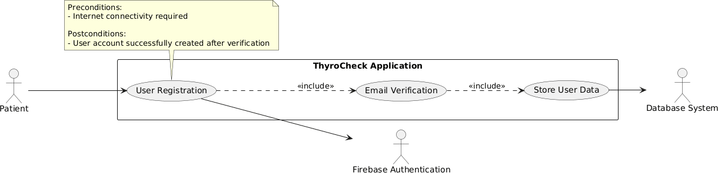

Figure 2 User Registration Use Case Diagram

- User Registration Use Case Diagram detail table.

Use Case ID | UC_01
Use Case Name | User Registration
Description | A new user can register on the app for being a verified user.
Primary Actor | Patient
Secondary Actor | System
Pre-Condition | Must enter valid details and must be connected to the internet.
Post-Condition | Gets verification email for verification
Basic Flow | Actor Action | System Action
 | User enters the registration details and submits | Details are verified and stored in Firebase Firestore and a confirmation email is sent.
Alternate Flow | Notification for registration failed is sent.

Table 20 User Registration Use Case Diagram

- User Login Use Case Diagram.
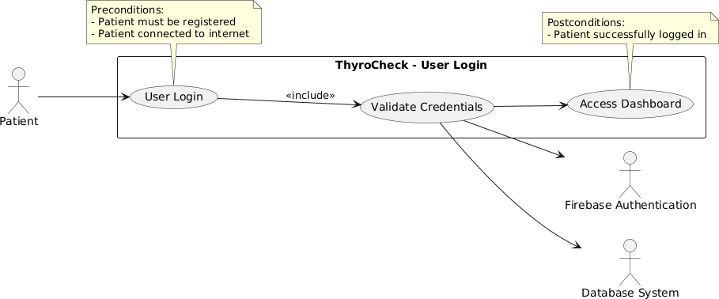

Figure 3 User Login Use Case Diagram

- User Login Use Case Table

Use Case ID | UC_02
Use Case Name | User Login
Description | A registered patient can log in to the app to access the dashboard of app
Primary Actor | Patient
Secondary Actor | System
Pre-Condition | Must enter valid credentials and must be connected to the internet.
Post-Condition | Patient successfully logged in and dashboard is accessible.
Basic Flow | Actor Action | System Action
 | User enters the credentials and submits | System validates credentials through Firebase access to the dashboard is granted.
Alternate Flow | Notification for registration failed is sent.

Table 21 User Login Use Case Table

- User Password Reset Use Case Diagram.

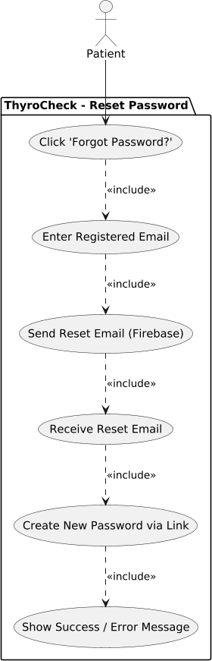

Figure 4 User Password Reset Use Case Diagram

- User Password Reset Use Case Table

Use Case ID | UC_03
Use Case Name | User Password Reset
Description | A registered patient can reset their password if they forget it, using their registered email and receiving a reset link.
Primary Actor | Patient
Secondary Actor | System, Firebase Authentication, Email Service
Pre-Condition | Patient must have a registered email and be connected to the internet.
Post-Condition | Patient successfully resets the password and can log in with the new password.
Basic Flow | Actor Action | System Action
 | User enters the credentials and submits | System validates credentials through Firebase access to the dashboard is granted.
Alternate Flow | If email is invalid or not registered, system shows error notification

Table 22 User Password Reset Use Case Table

- User Provides Smoking Status Use Case Diagram.

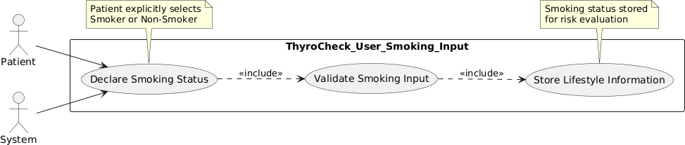

Figure 5 User Providing Smoking Status Use Case Diagram

- User Smoking Status Use Case Table
.

Use Case ID | UC_04
Use Case Name | User Provides Smoking Status.
Description | A registered patient provides information regarding their smoking status, which will be used for risk assessment in ThyroCheck.
Primary Actor | Patient
Secondary Actor | System
Pre-Condition | Patient must be logged in and have a valid account.
Post-Condition | Smoking status is successfully stored for further risk assessment.
Basic Flow | Actor Action | System Action
 | Patient selects smoking status from options or inputs manually. | System validates input and stores the smoking status in the database.
Alternate Flow | If the input is invalid or missing, ThyroCheck prompts the patient to provide valid smoking status.

Table 23 User Smoking Status Use Case Table

- Upload Thyroid Reports (PDF or image) Use Case Diagram.

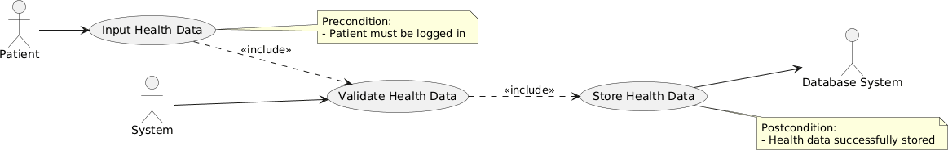

Figure 6 Upload Thyroid Reports Use Case Diagram

- Upload Thyroid Reports (PDF or image).

Use Case ID | UC_05
Use Case Name | Upload Thyroid Report
Description | A registered patient can upload a thyroid laboratory report in image or PDF format to the application for further analysis.
Primary Actor | Patient
Secondary Actor | System, Database System
Pre-Condition | Patient must have a registered email and be connected to the internet.
Post-Condition | Thyroid report is successfully uploaded and stored in the database for processing.
Basic Flow | Actor Action | System Action
 | Patient selects upload option and chooses a report file and uploads (image/PDF). | System validates the file format and size.
Alternate Flow | If the selected file format is unsupported or upload fails due to connectivity issues, ThyroCheck displays an error notification.

Table 24 Upload Thyroid Use Case Table

  - Flag OCR Errors and Prompt for re-upload Use Case Diagram.

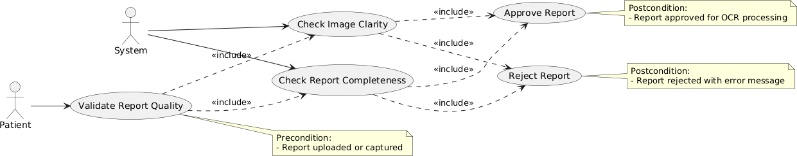

Figure 7 OCR Error & Prompt for Re-Uploading

  - Flag OCR Errors and Prompt for re-upload Use Case Table.

Use Case ID | UC_06
Use Case Name | OCR Error and Prompt for re-upload
Description | ThyroCheck checks the quality of the uploaded or captured thyroid report to ensure it is suitable for OCR processing.
Primary Actor | Patient
Secondary Actor | System
Pre-Condition | Patient has uploaded or captured a thyroid report.
Post-Condition | Report is validated and ready for OCR extraction or flagged for re-upload.
Basic Flow | Actor Action | System Action
 | Patient uploads or captures a thyroid report. | System checks image clarity, resolution, and format, If quality is sufficient, report moves to OCR extraction.
Alternate Flow | If report quality is insufficient, ThyroCheck flags the error and prompts patient to re-upload the report.

Table 25 Flag OCR Error and Prompt for Re-Uploading Use Case Table

  - Extract TSH, T3, and T4 values using OCR

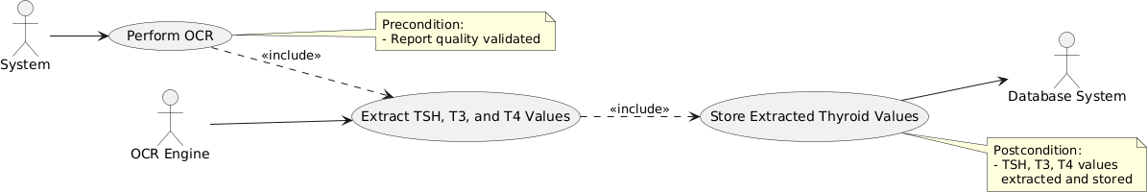

Figure 8 Extract TSH, T3 & T4 Value Using OCR Use Case Diagram

  - Extract TSH, T3, and T4 values using OCR Use Case Table.

Use Case ID | UC_07
Use Case Name | Extract TSH, T3, and T4 values using OCR
Description | ThyroCheck extracts Thyroid hormone values from the uploaded report using OCR technology.
Primary Actor | System
Secondary Actor | Patient
Pre-Condition | Report has passed quality validation.
Post-Condition | Thyroid hormone values are stored in the database for ML processing.
Basic Flow | Actor Action | System Action
 | Patient confirms report submission. | System performs OCR to extract TSH, T3, T4 values. Extracted values are stored in the database for ML processing.
Alternate Flow | If OCR fails or errors are detected, ThyroCheck prompts the patient to re- upload the report.

Table 26 Extract TSH, T3 & T4 Value using OCR Use Case Table

  - Storing Data for ML Processing Use Case Diagram.

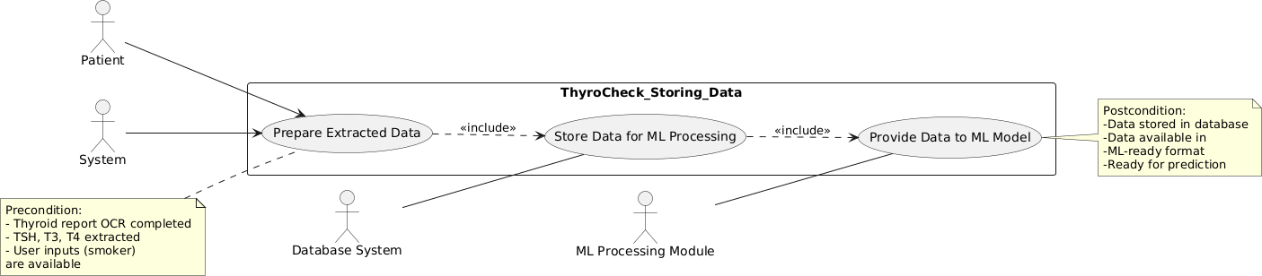

Figure 9 Storing Data for ML Processing Use Case Diagram

  - Storing Data for ML Processing Use Case Table

Use Case ID | UC_08
Use Case Name | Store Extracted Data for ML Processing
Description | ThyroCheck stores the extracted thyroid hormone values and user-provided data for machine learning analysis
Primary Actor | System
Secondary Actor | Database System, ML Model
Pre-Condition | Report data extracted successfully via OCR.
Post-Condition | Data stored in the database and ready for ML predictions
Basic Flow | Actor Action | System Action
 | Patient completes report submission. | System stores extracted values and related user data in database for ML processing.
Alternate Flow | If storage fails, ThyroCheck notifies the patient and retries data storage.

Table 27 Storing Data for ML Processing Use Case Table

  - Predict Hypertension Status Using ML Model Use Case Diagram.

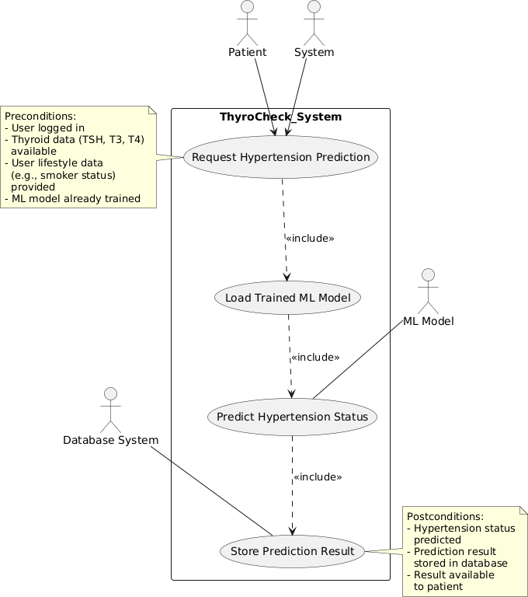
Figure 10 Predict Hypertension Status Using ML Model Use Case Diagram

- Predict Hypertension Status Using ML Model Use Case Table

Use Case ID | UC_09
Use Case Name | Predict Hypertension Status Using ML Model Use Case
Description | ThyroCheck predicts the patient’s hypertension status using a trained machine learning model.
Primary Actor | System
Secondary Actor | Patient, ML Model
Pre-Condition | Thyroid report data and user input successfully stored.
Post-Condition | Hypertension status predicted and saved for report generation.
Basic Flow | Actor Action | System Action
 | Patient submits data. | System runs ML model on stored values and predicts hypertension status, Prediction stored for generating report.
Alternate Flow | If ML prediction fails, system retries computation or alerts patient.

Table 28 Predict Hypertension Status Using ML Model Use Case Table

  - Risk Assessment Use Case Diagram.

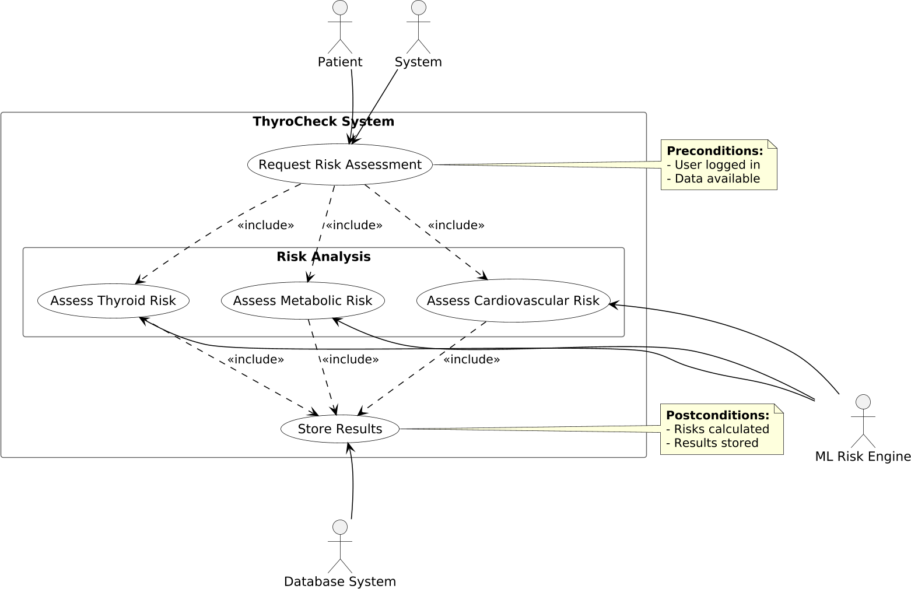

Figure 11 Risk Assessment Use Case Diagram

  - Risk Assessment Use Case Table

Use Case ID | UC_10
Use Case Name | Risk Assessment
Description | ThyroCheck assesses cardiovascular, metabolic, and thyroid-related risks based on extracted data and ML predictions.
Primary Actor | System
Secondary Actor | Patient
Pre-Condition | Patient data and ML predictions are available.
Post-Condition | Risk levels categorized (Low, Medium, High) and stored for report.
Basic Flow | Actor Action | System Action
 | Patient submits data. | System calculates risk levels for cardiovascular, metabolic, and thyroid complications. Results stored for report generation.
Alternate Flow | If data missing or inconsistent, system prompts patient to provide missing info.

Table 29 Risk Assessment Use Case Table

  - Generate PDF Report Use Case Diagram.
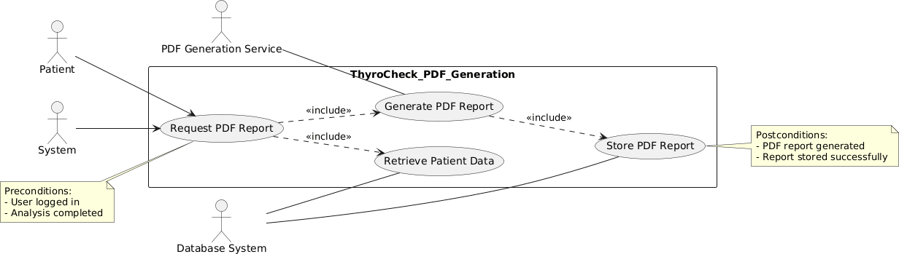

Figure 12 PDF Report Use Case Diagram

  - Generate PDF Report Use Case Table

Use Case ID | UC_11
Use Case Name | Generate PDF Report with Values and Predictions
Description | ThyroCheck generates a PDF report containing extracted values, ML predictions, and risk assessments.
Primary Actor | System
Secondary Actor | Patient
Pre-Condition | ML predictions and risk assessments are available.
Post-Condition | PDF report successfully generated and ready for download.
Basic Flow | Actor Action | System Action
 | Patient requests report. | System compiles data, predictions, and risk assessments into PDF format. PDF report stored and linked to patient account.
Alternate Flow | If PDF generation fails, system retries or alerts patient.

Table 30 Generate PDF Report Use Case Table

  - View and Download PDF Reports Use Case Diagram.
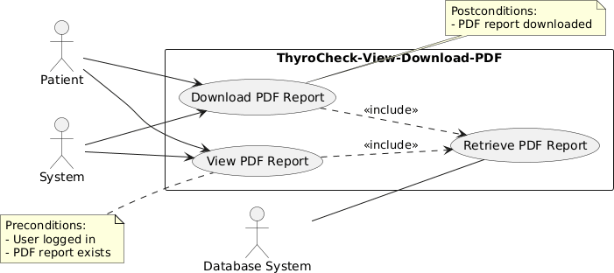

Figure 13 View & Download PDF Reports Use Case Diagram

  - View and Download Use Case Table.

Use Case ID | UC_12
Use Case Name | View and Download PDF Reports
Description | Patient can view or download generated PDF reports.
Primary Actor | Patient
Secondary Actor | System
Pre-Condition | PDF report is generated and stored.
Post-Condition | Patient successfully views or downloads the report.
Basic Flow | Actor Action | System Action
 | Patient selects report to view/download. | System retrieves PDF from storage and displays download option. PDF downloaded to patient device.
Alternate Flow | If PDF unavailable or download fails, system displays error and prompts retry.

Table 31 View and Download Use Case Table

  - Notifying User PDF Report is ready Use Case Diagram.
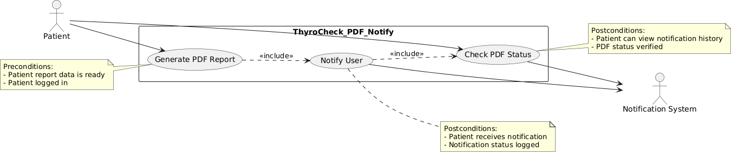

Figure 14 Notifying User PDF Report is ready Use Case Diagram

  - Notifying User PDF Report Use Case Table.

Use Case ID | UC_13
Use Case Name | Notify Users When PDF Report is Ready
Description | ThyroCheck sends notifications to patients when their PDF reports are generated and ready for download.
Primary Actor | Patient
Secondary Actor | Notification System
Pre-Condition | PDF report generated successfully.
Post-Condition | Patient receives notification and can download the report.
Basic Flow | Actor Action | System Action
 | Patient waits for report. | System sends notification via app or email. Notification status logged.
Alternate Flow | If notification fails, system retries or alerts patient.

Table 32 Notifying User PDF Report is ready Use Case Table

  - Storage and Historical Reports and Result Use Case Diagram.

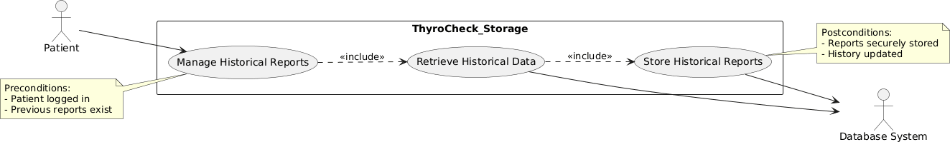

Figure 15 Storage and Historical Reports & Results Use Case Diagram

  - Storage and Historical Reports and Result Use Case Table.

Use Case ID | UC_14
Use Case Name | Notify Users When PDF Report is Ready
Description | ThyroCheck sends notifications to patients when their PDF reports are generated and ready for download.
Primary Actor | Patient
Secondary Actor | Notification System
Pre-Condition | PDF report generated successfully.
Post-Condition | Patient receives notification and can download the report.
Basic Flow | Actor Action | System Action
 | Patient waits for report. | System sends notification via app or email. Notification status logged.
Alternate Flow | If notification fails, system retries or alerts patient.

Table 33 Storage and Historical Reports and Result Use Case Table

  - Securely Store User Data Use Case Diagram.

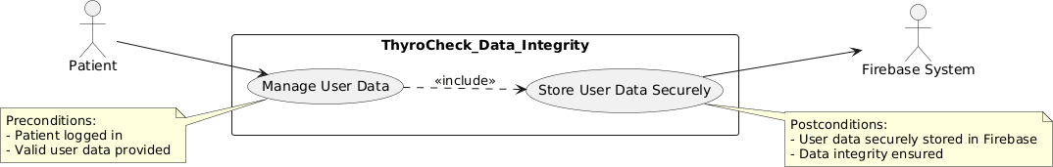

Figure 16 Securely Store User Data Use Case Diagram

  - Securely Store User Data Use Case Table

Use Case ID | UC_15
Use Case Name | Securely Store User Data in Firebase
Description | ThyroCheck stores patient data securely in Firebase, ensuring confidentiality and integrity.
Primary Actor | Patient
Secondary Actor | Firebase System
Pre-Condition | Patient logged in and provides valid data.
Post-Condition | Data stored securely with encryption and integrity check.
Basic Flow | Actor Action | System Action
 | Patient provides data. | System validates data and stores it securely in Firebase.
Alternate Flow | If storage fails, system retries or alerts patient.

Table 34 Securely Store User Data Use Case Table

  - Handle Multiple Users Securely Data Use Case Diagram.

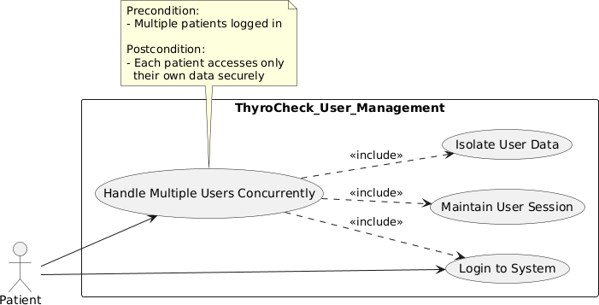

Figure 17 Handle Multiple User Use Case Diagram

  - Handle Multiple Users Securely Data Use Case Table

Use Case ID | UC_16
Use Case Name | Handle Multiple Users Securely
Description | ThyroCheck manages multiple users concurrently, ensuring secure authentication and session management.
Primary Actor | Patient
Secondary Actor | Firebase System
Pre-Condition | Users are registered and logged in.
Post-Condition | Sessions handled securely, concurrent users supported without data loss.
Basic Flow | Actor Action | System Action
 | Patient provides data. | System validates data and stores it securely in Firebase.
Alternate Flow | If storage fails, system retries or alerts patient.

Table 35 Handle Multiple Users Securely Data Use Case Table

  - Manage Cloud Storage Use Case Diagram.
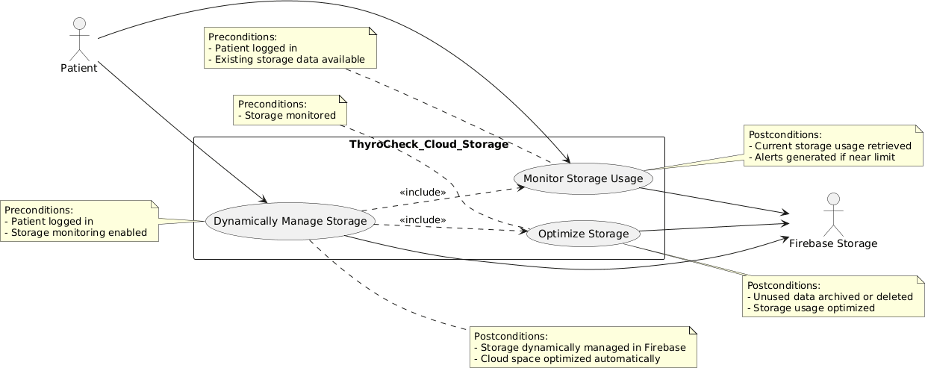

Figure 18 Manage Cloud Storage Use Case Diagram

  - Manage Cloud Storage Use Case Table

Use Case ID | UC_17
Use Case Name | Dynamically Manage Cloud Storage Usage
Description | ThyroCheck monitors and optimizes cloud storage dynamically to ensure efficient usage
Primary Actor | Patient
Secondary Actor | Firebase Storage
Pre-Condition | Patient logged in and storage monitoring enabled.
Post-Condition | Cloud storage dynamically managed and optimized automatically.
Basic Flow | Actor Action | System Action
 | Patient uploads or deletes reports. | System monitors storage usage and dynamically optimizes storage.Alerts patient if storage near limit and archives/deletes unused data.
Alternate Flow | If storage optimization fails, system retries or notifies patient/admin.

Table 36 Manage Cloud Storage Use Case Table

Chapter 4: Design

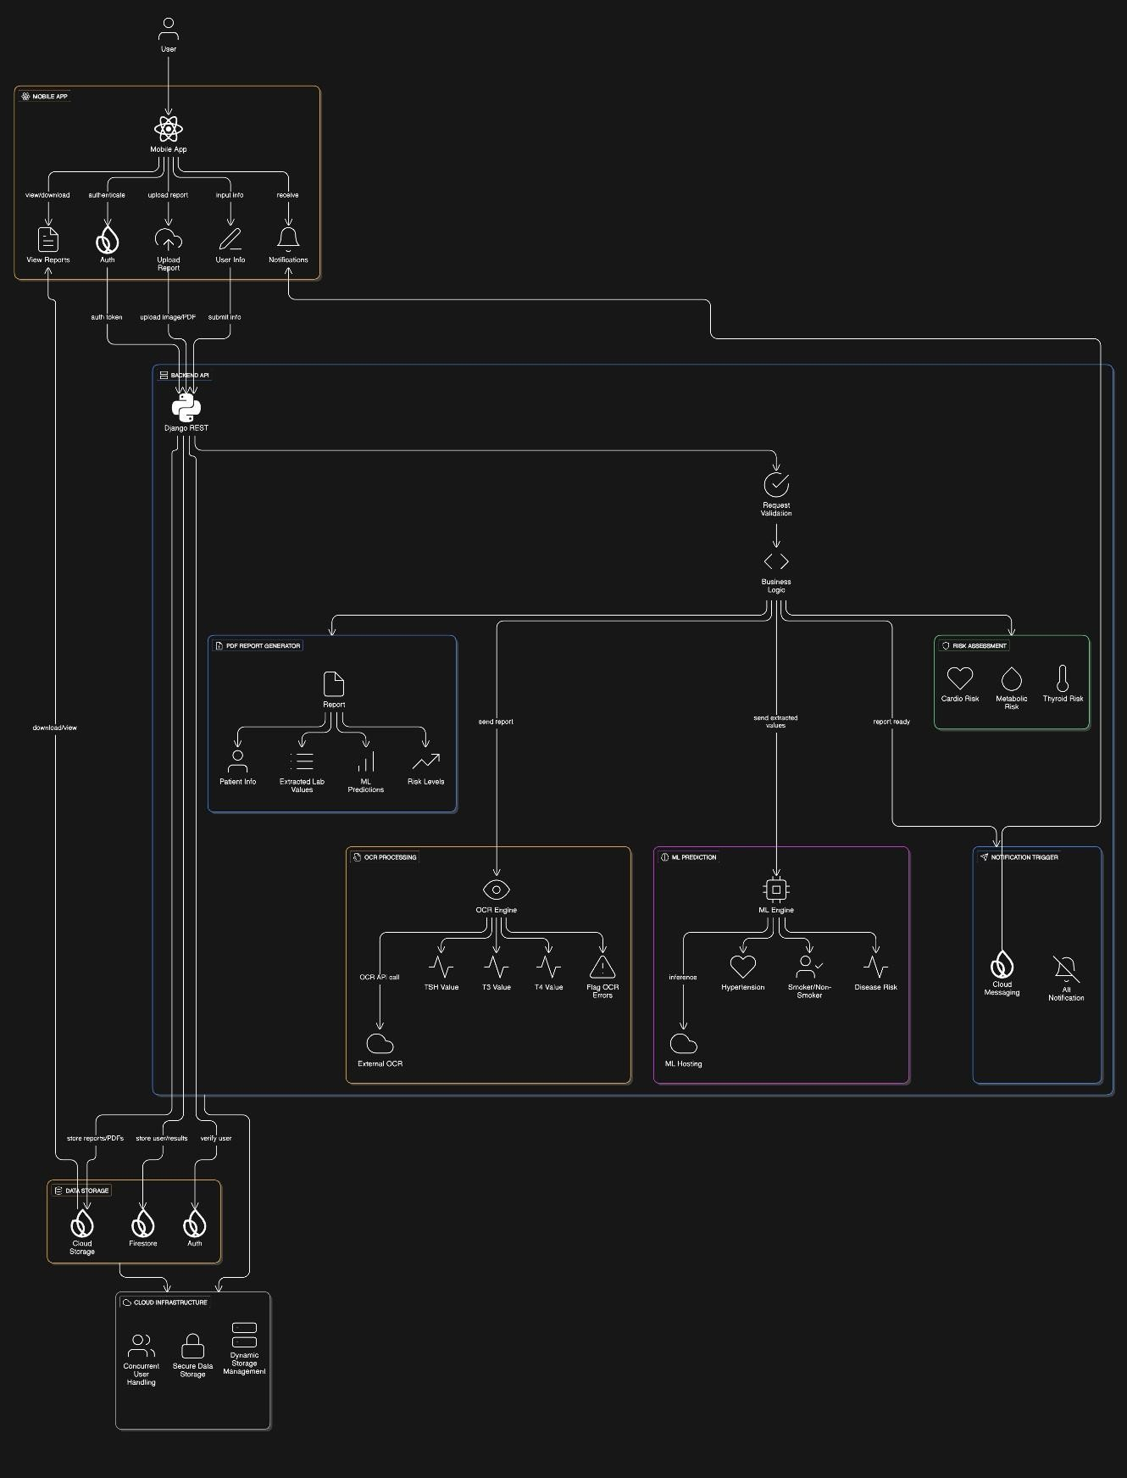
Architecture Diagram
Figure 19 Architecture Diagram

ERD with data dictionary
There may be changes in data variables in time when implementing the ML functionality in the second part of the FYP

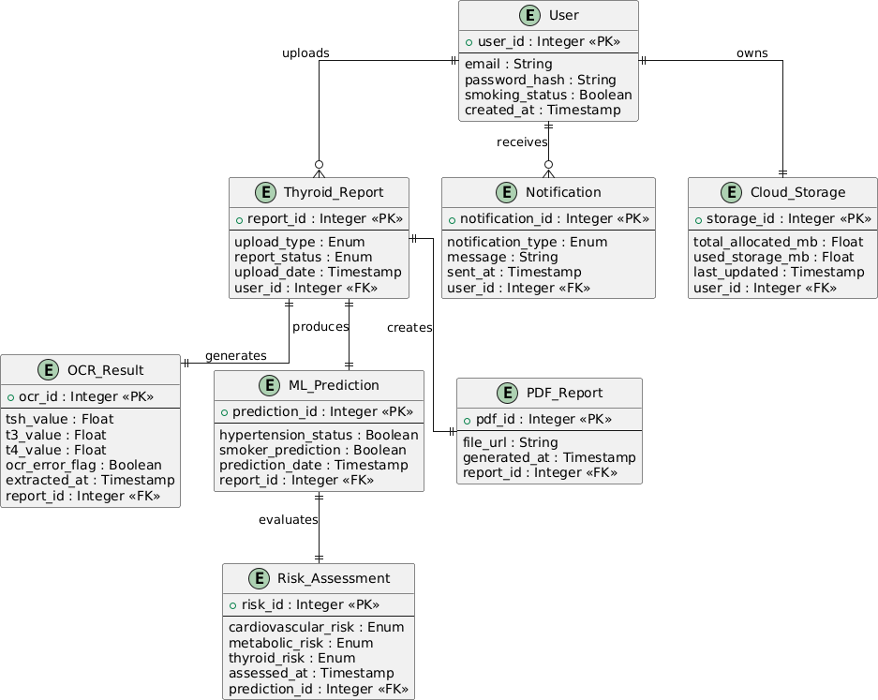

Figure 20 ERD with Data Dictionary

Data Flow diagram

Data flow diagram includes two levels and both of them are given below:

The level 0

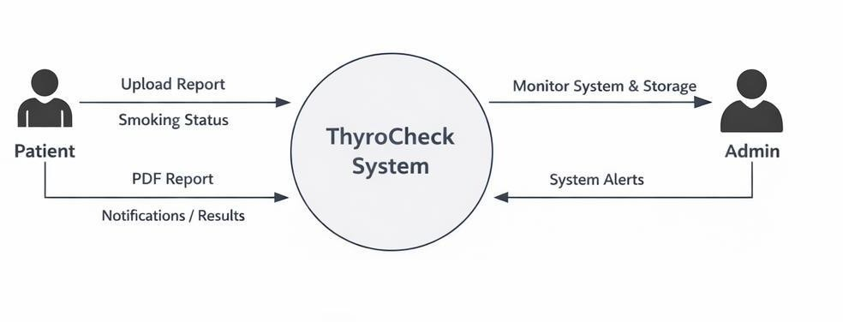
Figure 21 Data Flow Diagram Level 0

The level 1
The flow of information outside ThyroCheck is defined in this level as shown below:

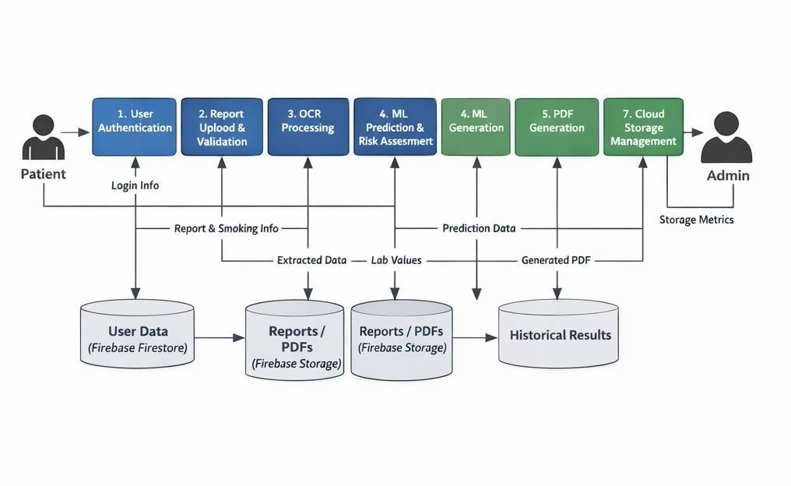
Figure 22 Data Flow Diagram Level 1

Class Diagram

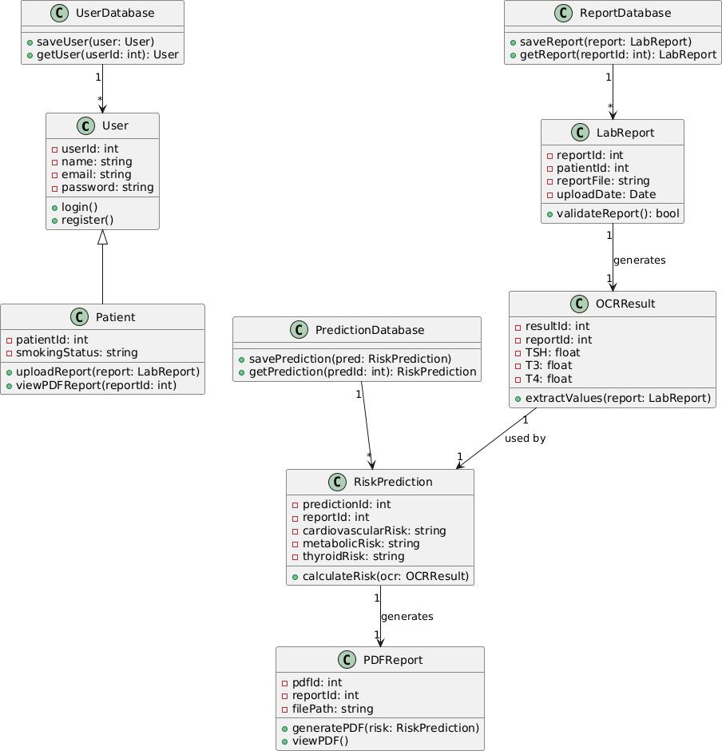

Figure 23 Class Diagram

Activity Diagram

The Activity Diagrams are mentioned and in detail for every aspect of the functionality of the application.

- User Registration Activity Diagram.
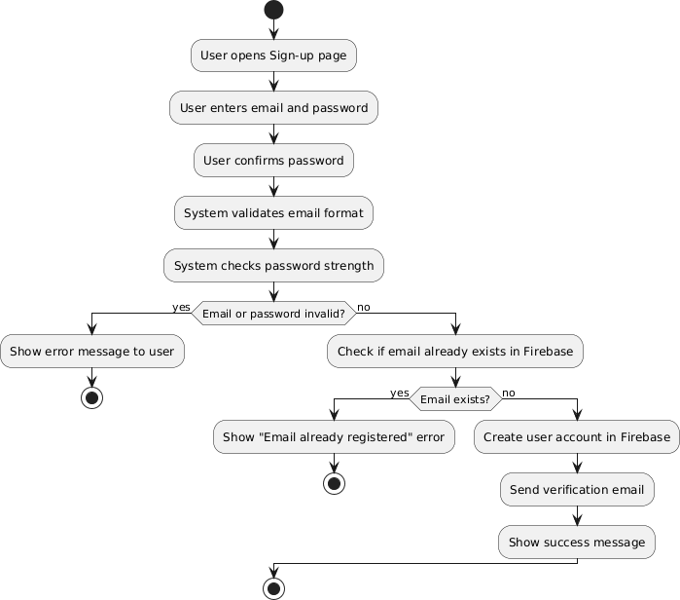

Figure 24 User Registration Activity Diagram

- User Login Activity Diagram.

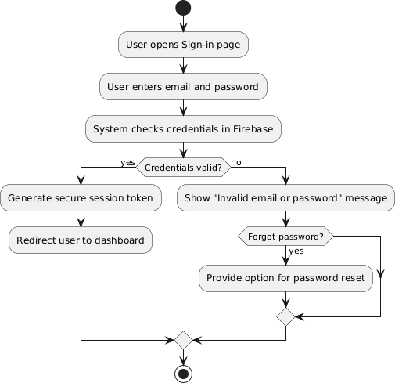

Figure 25 User Login Activity Diagram

- User Password Reset Activity Diagram.

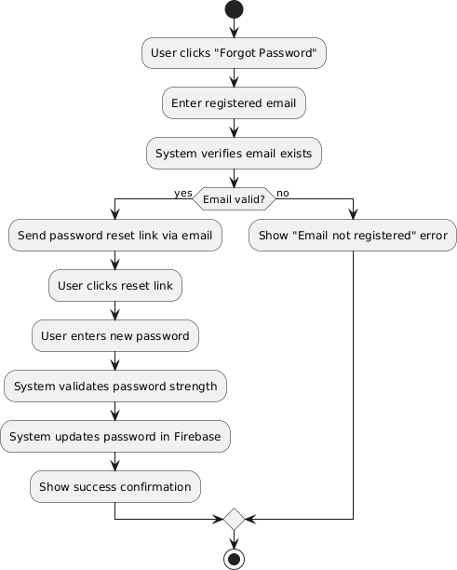

Figure 26 Password Reset Activity Diagram

- User Provides Smoking Status Activity Diagram.

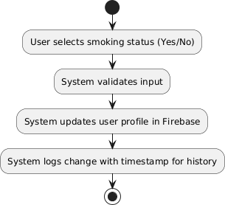

Figure 27 User Provide Smoking Status Activity Diagram

- Upload Thyroid Reports (PDF or image) Activity Diagram.

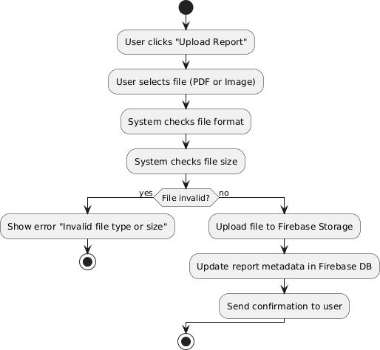

Figure 28 Upload Thyroid Report Upload Activity Diagram

- Flag OCR Errors and Prompt for re-upload Activity Diagram.

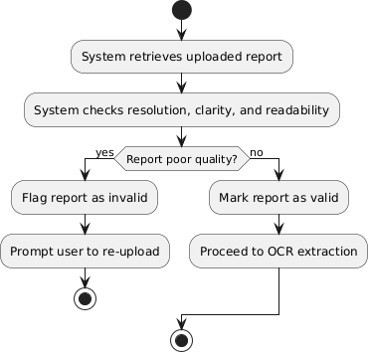

Figure 29 Flag OCR Error & Prompt for Re-Upload Activity Diagram

- Extract TSH, T3, and T4 values using OCR Activity Diagram
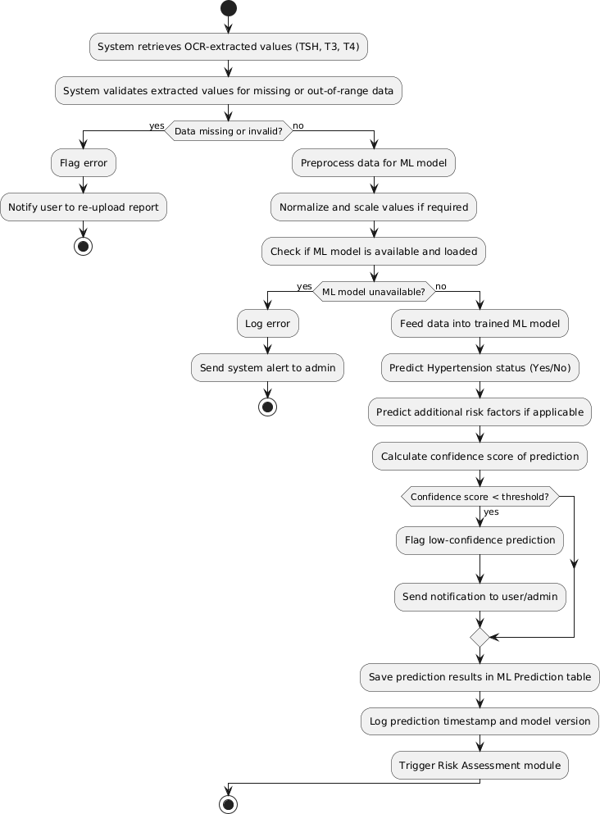
Figure 30 Extraction of TSH, T3 and T4 values using OCR

- Risk Assessment Activity Diagram.
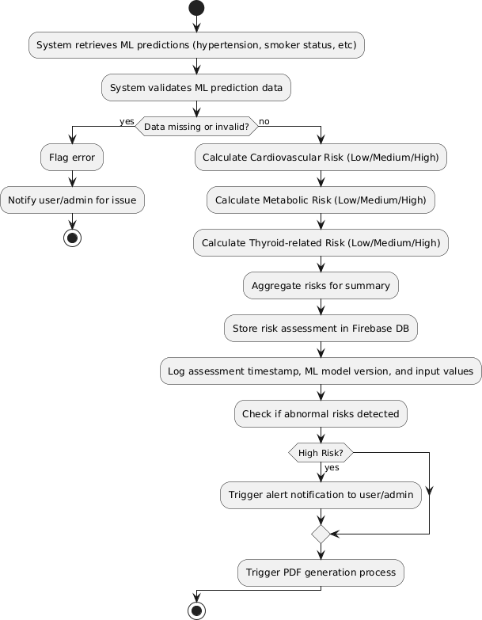

Figure 31 Risk Assessment Diagram

- Generate PDF Report Activity Diagram.

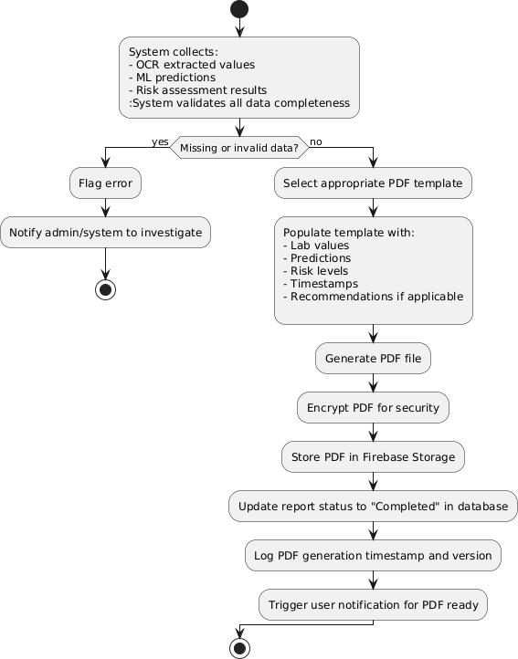

Figure 32 Generate PDF Report Activity Diagram

- View and Download PDF Reports Activity Diagram.

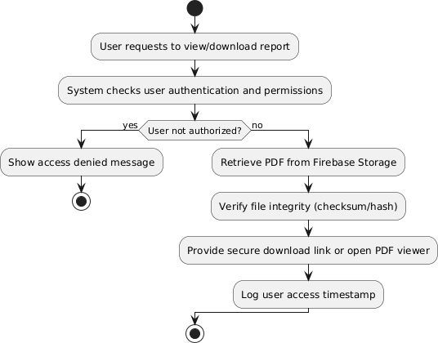

Figure 33 View and Download PDF Reports Activity Diagram

- Store and manage historical reports and results Activity Diagram
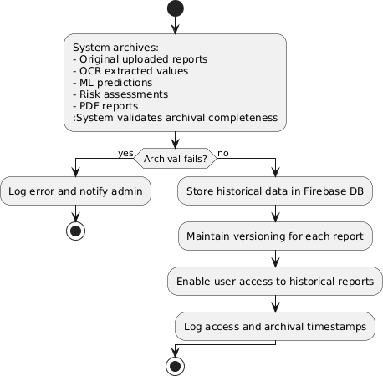

Figure 34 Store and Manage historical Reports and Results Activity Diagram

- Securely store user data in Firebase Activity Diagram

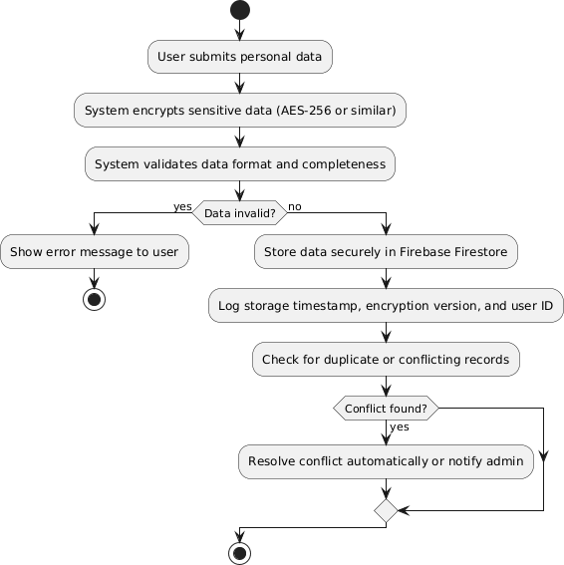

Figure 35 Securely Store Data in Firebase Activity Diagram

  - Handle multiple users securely Activity Diagram

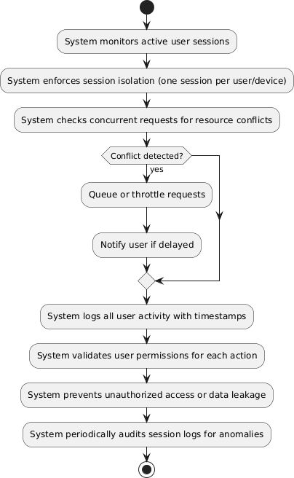

Figure 36 Handle Multiple users securely Activity Diagram

  - Dynamically manage cloud storage usage Activity Diagram
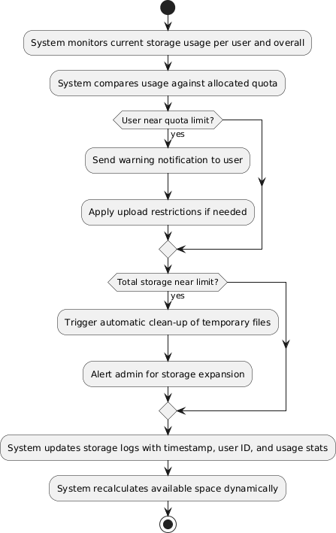

Figure 37 Managing Cloud Storage Usage Activity Diagram

Sequence Diagram

- User Registration Sequence Diagram.
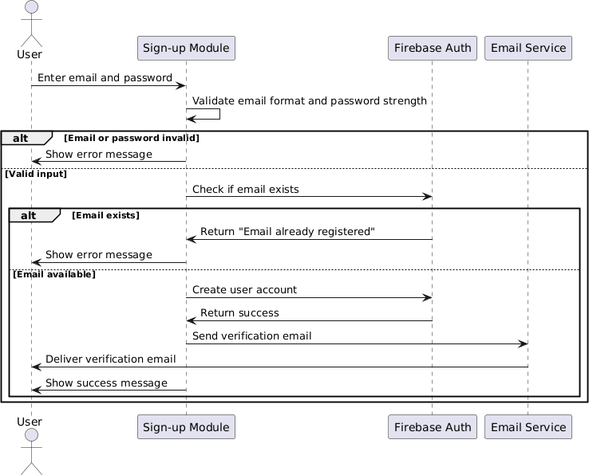

Figure 38 Sequence Diagram User Registration

- User Sign-in Sequence Diagram.

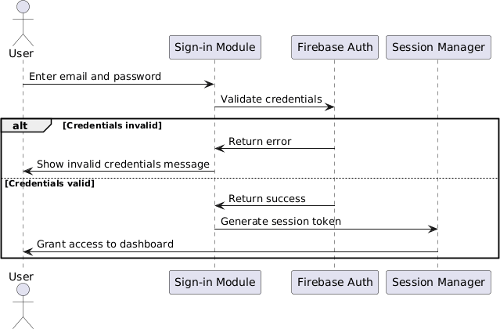

Figure 39 Sequence Diagram User Sign-In

- User Password Reset Sequence Diagram.

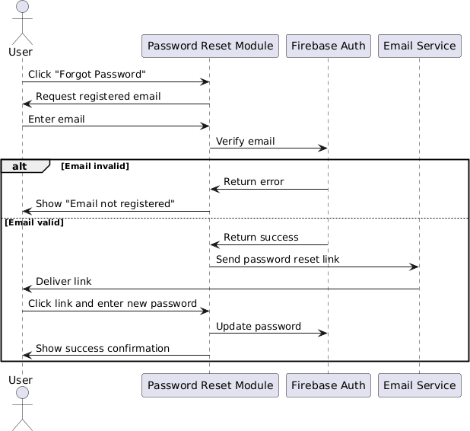
Figure 40 Sequence Diagram Password Reset

- User Provides Smoking Status Sequence Diagram.

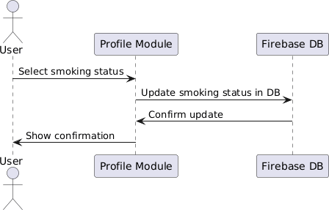

Figure 41 Sequence Diagram Smoking Status

  - Upload thyroid reports (PDF or image)

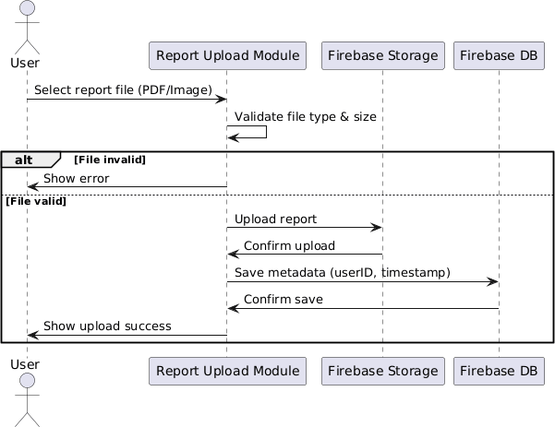

Figure 42 Sequence Diagram Upload Thyroid Reports

- Validate uploaded or captured report quality

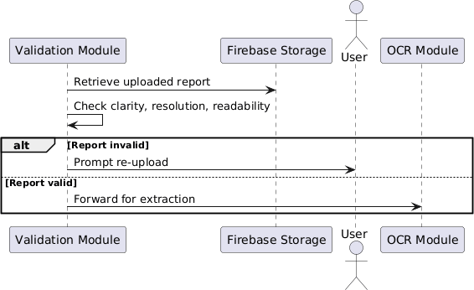

Figure 43 Sequence Diagram Validate Uploaded Capture Quality

  - Extract TSH, T3, T4 Value Sequence Diagram

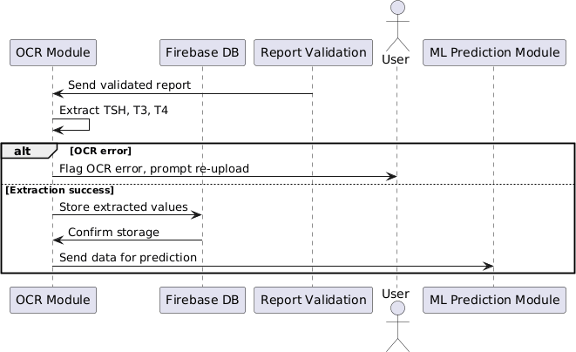

Figure 44 Sequence Diagram Extract TSH, T3 & T4 Values

  - Risk Assessment Sequence Diagram.

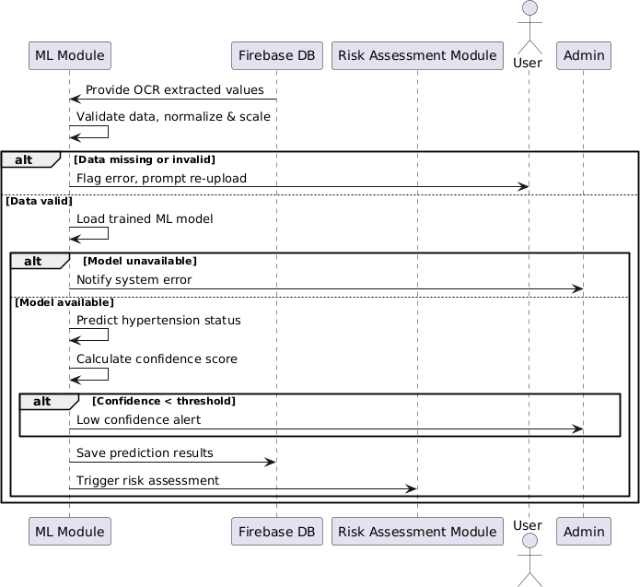
Figure 45 Sequence Diagram Risk Assessment

  - Generate PDF report with values and predictions

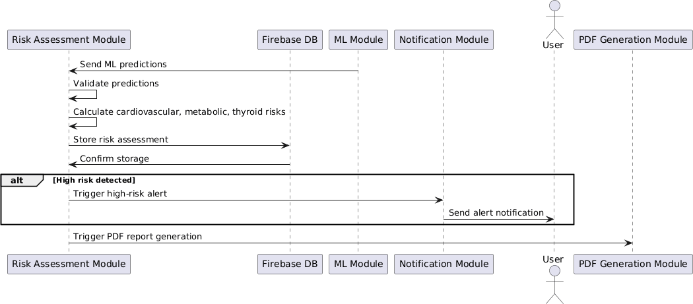

Figure 46 Sequence Diagram PDF Report Generation

  - View and download PDF reports Sequence Diagram
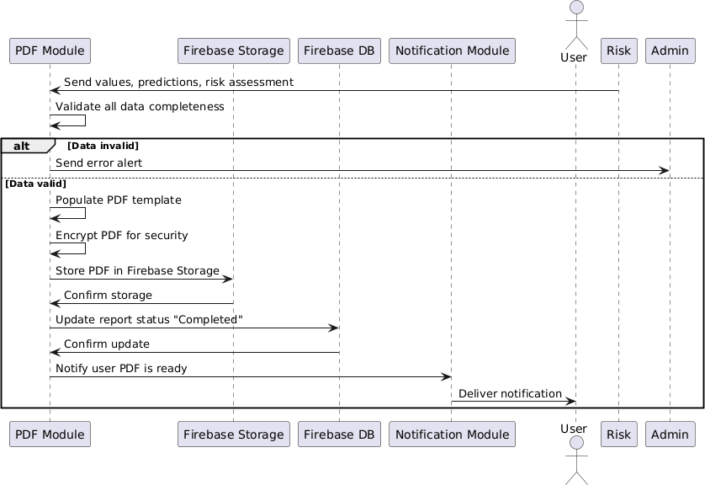

Figure 47 Sequence Diagram View Download PDF Report

  - Store and manage historical reports and results Sequence Diagram.

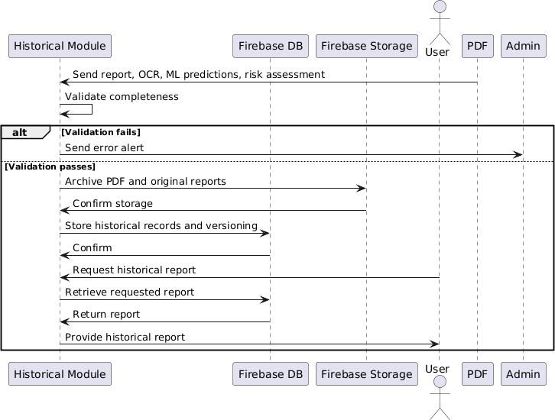

Figure 48 Sequence Diagram Store and Manage Historical Reports and Results

  - Handle multiple users securely Sequence Diagram

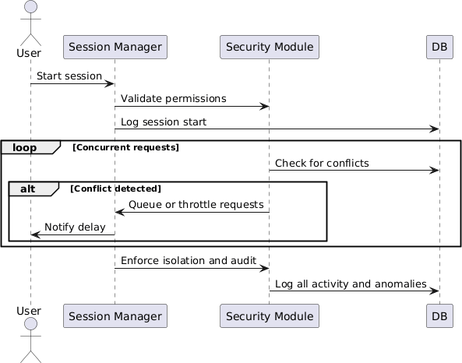

Figure 49 Sequence Diagram Handle Multiple Users

  - Dynamically manage cloud storage usage

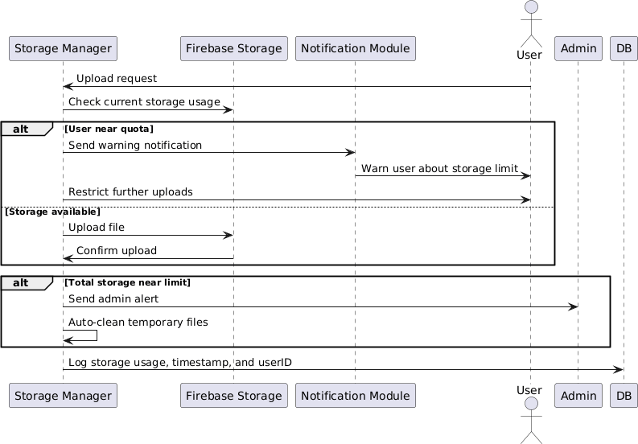

Figure 50 Sequence Diagram Dynamically Manage Cloud Storage

State Transition Diagram
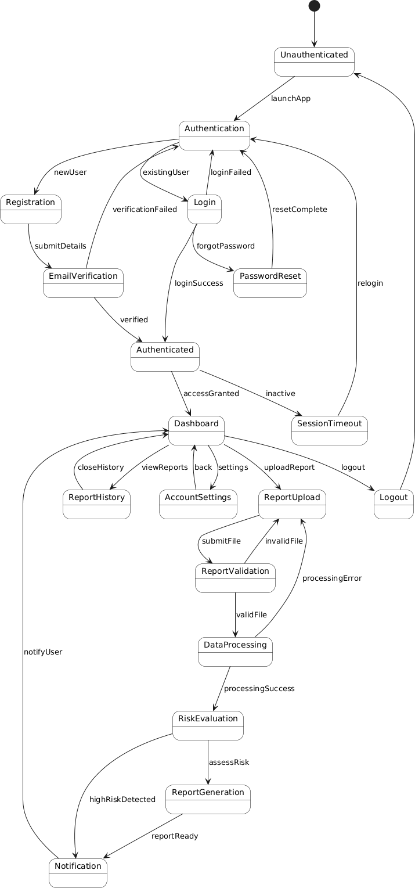

Figure 51 State Transition Diagram

Component Diagram

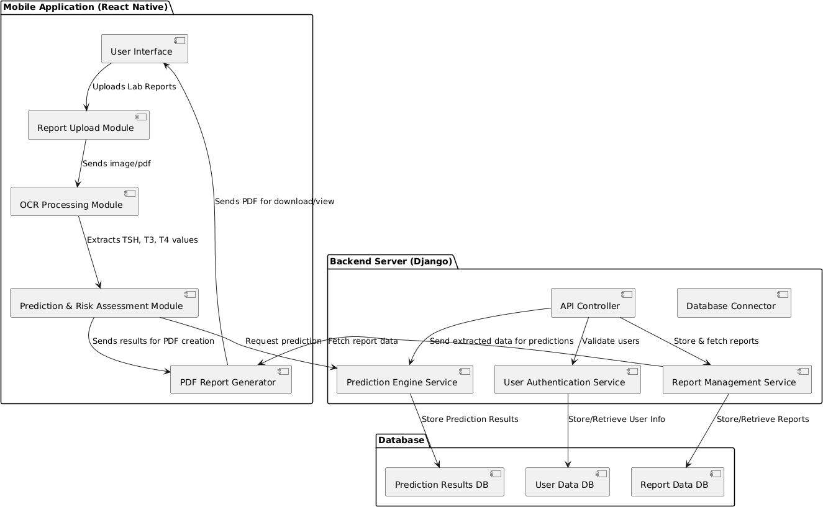

Figure 52 Component Diagram

Deployment Diagram

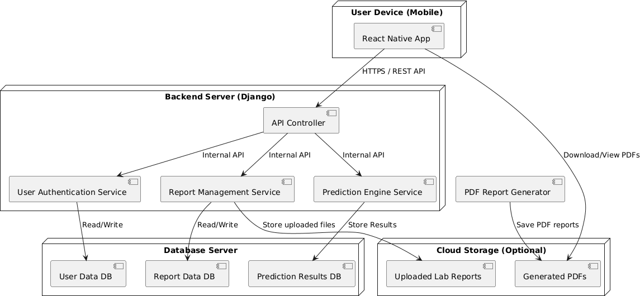
Figure 53 Deployment Diagram

Chapter 5: User Manual

The user interface has been built using React Native with Expo Go, which makes it easier to design and test the app. Later, the same React Native code can be reused when building the full app with React Native CLI. Following are the UI/UX pages (will be updated in the future) for the app and the screen shots of the UI/UX are given below.

Login Page
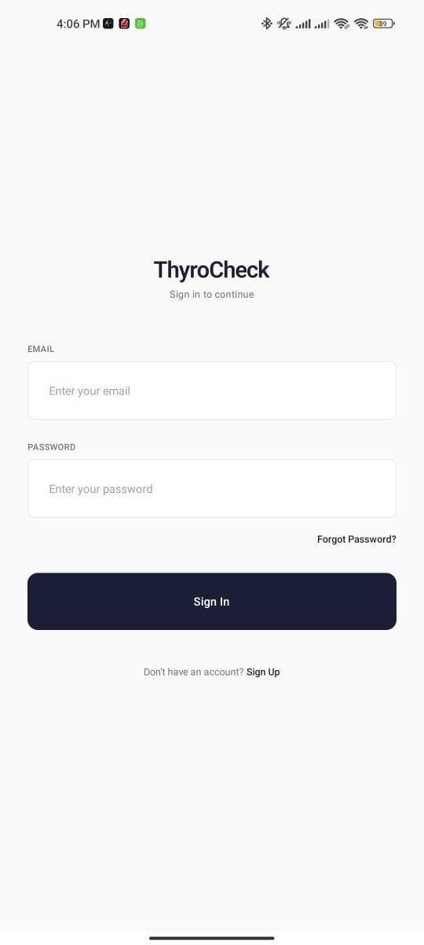
Figure 54 User Interface - Login Page

- Sign Up Page

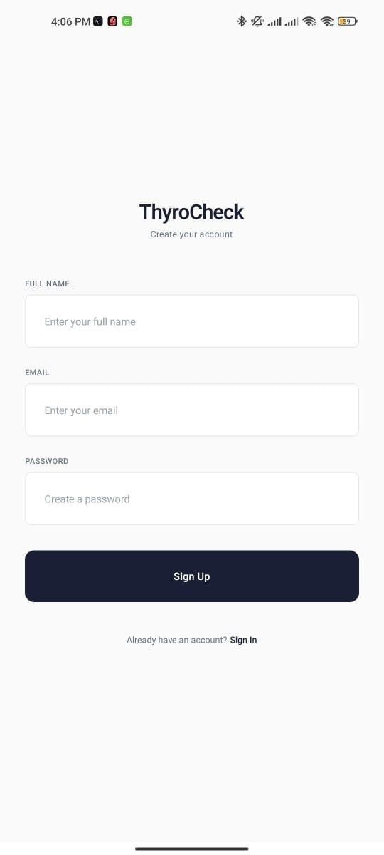

Homepage
Figure 55 User Interface - Sign Up Page

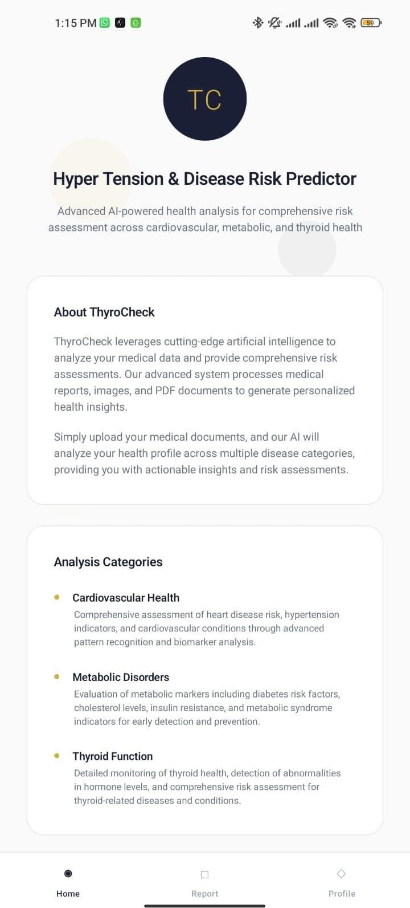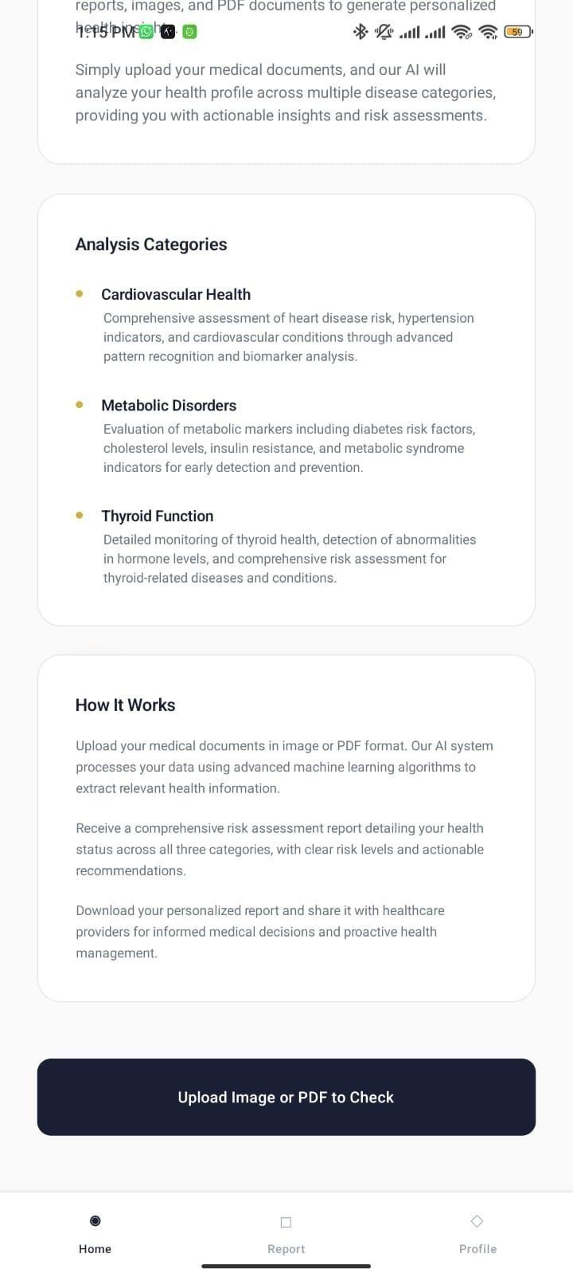
Figure 56 User Interface - Home Page

Profile Page
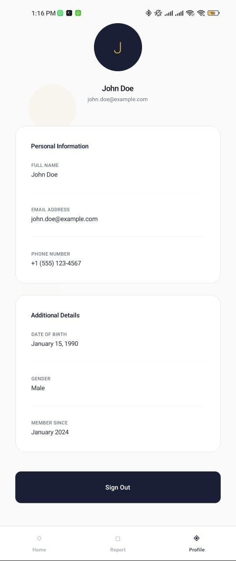

Figure 57 User Interface - Profile Page

Report Page
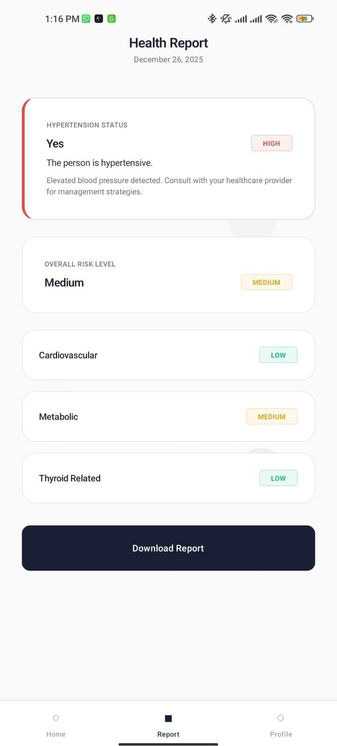

Figure 58 User Interface - Report Page

Password Reset Page
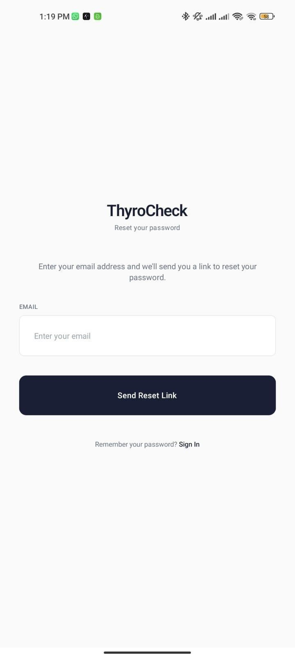

Figure 59 User Interface - Password Reset Page

References:

  - Sommerville, I. (2016). Software Engineering (10th ed.). Pearson Education.

  - IEEE Computer Society. (1998). IEEE Recommended Practice for Software Requirements Specifications (IEEE Std 830-1998).

  - Forouzan, B. A. (2012). Data Communications and Networking (5th ed.). McGraw-Hill.

  - Smith, L. (2007). An overview of the Tesseract OCR engine. Proceedings of the Ninth International Conference on Document Analysis and Recognition (ICDAR).
  - Firebase Documentation.
  - Google LLC. Firebase Authentication and Firestore Documentation.
  - React Native Documentation.
  - Meta Platforms Inc. React Native Official Docs.
  - Pedregosa, F., et al. (2011). Scikit-learn: Machine learning in Python. Journal of Machine Learning Research, 12, 2825–2830.
  - World Health Organization (WHO).
  - Guidelines on Thyroid Disorders and Cardiovascular Risk Assessment.
  - Kaggle Datasets.
  - Thyroid Disease and Hormone Level Datasets.
  - PlantUML Documentation.
  - Open-source UML diagram generation tool

Appendix

Appendix A: Functional Requirements Tables
This appendix contains detailed functional requirement specifications for the ThyroCheck system, including user registration, authentication, report upload, OCR processing, machine learning predictions, risk assessment, and report generation. Each functional requirement is documented using a standardized template consisting of ID, name, description, actors, preconditions, postconditions, basic flow, and alternate flow.

Appendix B: Use Case Diagrams
This appendix includes all PlantUML-based use case diagrams developed for the ThyroCheck project. The diagrams visually represent interactions between actors and the system for the following functionalities:
  - User Registration
  - User Login
  - Password Reset
  - Upload Thyroid Lab Report
  - Validate Report Quality
  - OCR-based Extraction of TSH, T3, and T4
  - OCR Error Handling and Re-upload
  - User Health Attribute Input (Smoking Status, Hypertension Status)
  - Store Extracted Data for ML Processing
  - Hypertension Prediction using ML Model
  - Risk Assessment (Cardiovascular, Metabolic, Thyroid-related)
  - PDF Report Generation
  - View and Download Reports
  - Manage Historical Reports
  - Handle Multiple Users Concurrently
All diagrams follow UML standards and are generated using PlantUML.

Appendix C: Machine Learning Model Details
This appendix provides an overview of the machine learning models trained for ThyroCheck, including:
  - Dataset description and preprocessing steps
  - Feature selection (TSH, T3, T4, smoking status, hypertension status)
  - Model training approach
  - Evaluation metrics (accuracy, precision, recall)
  - Limitations of predictions due to dataset constraints

The ML models are trained by the project team and integrated into the system for prediction and risk assessment.

Appendix D: OCR and Data Extraction Process
This appendix documents the OCR workflow used to extract thyroid hormone values from uploaded laboratory reports, including:
  - Image quality validation
  - OCR processing using Tesseract
  - Extraction of relevant hormone values
  - Error handling and re-upload mechanism

Appendix E: Tools and Technologies
The following tools and technologies were used in the development of ThyroCheck:
  - React Native (Mobile Application)
  - Firebase Authentication
  - Firebase Firestore
  - Firebase Storage
  - Python (Machine Learning & OCR)
  - Tesseract OCR
  - PlantUML (Diagrams)
  - PDF Generation Libraries

